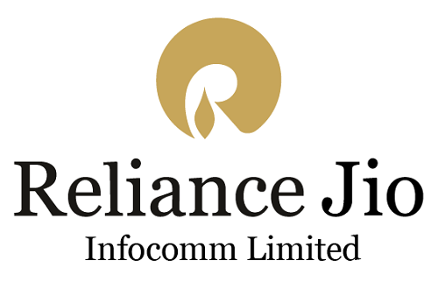

****

**A REPORT**

**ON**

**RELIANCE JIO COMPANY**

**COURSE:**

B.E, Information Technology,

Rajiv Gandhi Institute of Technology

**Preparation:**

This document is prepared by the following:

|  |  |  |  |
| --- | --- | --- | --- |
| **Sr No.** | **Student Name** | **Roll No.** | **Batch** |
| **1** | **Atharva Patil** | **550** | **T3** |
| **2** | **Atharva Rajadhyaksha** | **554** | **T3** |
| **3** | **Vedant Raj** | **553** | **T3** |
| **4** | **Vaishnavi Pomendkar** | **552** | **T3** |
| **5** | **Suman Mhalsank** | **542** | **T3** |

## ACKNOWLEDGEMENT

## We would like to offer a special thanks to Dr. Sunil B. Wankhade, the head of the Information Technology Department, MCT Rajiv Gandhi Institute of Technology for Providing us with the opportunity to prepare and present this report, as well as providing all the necessary resources and the excellent faculty to make all our efforts successful.

## We would like to express our gratitude to our project supervisor Dr. Rinku Sharma for her invaluable inputs and continued support in making this report possible.

## We also thank all those people who have painstakingly and patiently put their time and efforts to make our report a success.

## Last but not the least we thank all those who have in a way or the other contributed for the successful completion of the report.

## 

**ABSTRACT**

JIO is owned by the Reliance Industries Limited, which is amongst the largest and well known companies of the world. Reliance Jio Infocomm Ltd (popularly known as Jio), is an Indian mobile network

operator launched commercially on September 5, 2016. Owned by Reliance Indus

tries, the entry of Jio revolutionised the telecommunication sector. In this project

the success story of this recent entrant and management principles adopted by the

company were analysed on the basis of researches and studies conducted in these

ﬁelds. The organisational structure, planning and marketing strategy, staﬃng and

recruitment, SWOT analysis, PEST analysis, promotional strategy, the impact of Jio

launch, Government policies, controversies surrounding Reliance Jio, its ventures,

collaborations and future projects were also discussed in detail.

**FORWARDING LETTER**

**DATE:**

Dr. Rinku Sharma

Respected Ma’am,

We have the honour to represent the informative report on “JIO”.

As the authors we would like to place on the record the great help we received from you, who has acted as a guide throughout the duration of preparation of this report.

We would like to express our personal appreciation for the assistance from you and close co-operation in which we have worked.

Thanking you,

Yours sincerely,

TE IT

Batch: -T3

## Table of Contents

Chapter 1: Overview

* 1. History……………………………………………………………………
  2. Organization Chart ………………………………………………………
  3. Vision……………………………………………………………………..
     1. Vision of Company……………………………………………………….
     2. Vision of Chairperson……………………………………………………..
  4. Mission……………………………………………………………………..
  5. Subsidiaries…………………………………………………………………

Chapter 2: Products and Services………………………………………………….

2.1 Products…………………………………………………………………………

2.2 Broadband Services…………………………………………………………

2.3 Cloud Services………………………………………………………………..

Chapter 3: Business Roadmap……………………………………………………….

3.1 Business Model…………………………………………………………………..

3.2 Marketing Strategies…………………………………………………………….

3.3 Business Analysis………………………………………………………………..

Chapter 4: New Technologies………………………………………………………

4.1 Technology Paradigms…………………………………………………………..

4.2 Future Products

Chapter 5: Comparative Analysis

Chapter 6: Achievements

Chapter 7: Corporate Social Responsibilities

Chapter 8: Conclusion

Bibliography

## HISTORY

The company was registered in [Ambawadi](https://en.wikipedia.org/wiki/Ambawadi" \o "Ambawadi), Ahmedabad ([Gujarat](https://en.wikipedia.org/wiki/Gujarat)) on 15 February 2007 as Reliance Jio Infocomm Limited. In June 2010, [Reliance](https://en.wikipedia.org/wiki/Reliance_Industries) Industries Ltd (RIL) bought a 95% stake in Infotel Broadband Services Limited (IBSL) for ₹4,800 crore (US$690 million). Although unlisted, IBSL was the only company that won broadband spectrum in all 22 circles in India in the 4G auction that took place earlier that year. Later continuing as RIL's telecom subsidiary, Infotel Broadband Services Limited was renamed as Reliance Jio Infocomm Limited (RJIL) in January 2013.

In June 2015, Jio announced that it would start its operations all over the country by the end of 2015. However, four months later in October, the company's spokesmen sent out a press release stating that the launch was postponed to the first quarter of the financial year 2016–2017.

Later, in July, a [PIL](https://en.wikipedia.org/wiki/Public_interest_litigation_in_India) filed in the Supreme Court by an NGO called the [Centre for Public Interest Litigation](https://en.wikipedia.org/wiki/Centre_for_Public_Interest_Litigation), through [Prashant Bhushan](https://en.wikipedia.org/wiki/Prashant_Bhushan), challenged the grant of a pan-India licence to Jio by the Government of India. The PIL also alleged that Jio was allowed to provide voice telephony along with its [4G data service](https://en.wikipedia.org/wiki/4G), by paying an additional fee of just ₹165.8 crore (US$24 million) which was arbitrary and unreasonable, and contributed to a loss of ₹2,284.2 crore (US$330 million) to the exchequer.

The Indian [Department of Telecommunications](https://en.wikipedia.org/wiki/Department_of_Telecommunications) (DoT), however, refuted all of CAG's claims. In its statement, DoT explained that the rules for 3G and BWA spectrum didn't restrict BWA winners from providing voice telephony. As a result, the PIL was revoked, and the accusations were dismissed.

### Beta launch

The 4G services were launched internally to Jio's partners, its staff and their families on 27 December 2015. Bollywood actor [Shah Rukh Khan](https://en.wikipedia.org/wiki/Shah_Rukh_Khan), who is also the brand ambassador of Jio, kickstarted the launch event which took place in Reliance Corporate Park in [Navi Mumbai](https://en.wikipedia.org/wiki/Navi_Mumbai), along with celebrities like musician [A R Rahman](https://en.wikipedia.org/wiki/A_R_Rahman), actors [Ranbir Kapoor](https://en.wikipedia.org/wiki/Ranbir_Kapoor) and [Javed Jaffrey](https://en.wikipedia.org/wiki/Javed_Jaffrey" \o "Javed Jaffrey), and filmmaker [Rajkumar Hirani](https://en.wikipedia.org/wiki/Rajkumar_Hirani). The closed event was witnessed by more than 35000 [RIL](https://en.wikipedia.org/wiki/Reliance_Industries_Limited) employees some of whom were virtually connected from around 1000 locations including [Dallas](https://en.wikipedia.org/wiki/Dallas) in the [US](https://en.wikipedia.org/wiki/US).

### Commercial launch

The company commercially launched its services on 5 September 2016. Within the first month, Jio announced that it had acquired 16 million subscribers. Jio crossed 50 million subscriber mark in 83 days since its launch, subsequently crossing 100 million subscribers on 22 February 2017. By October 2017 it had about 130 million subscribers.

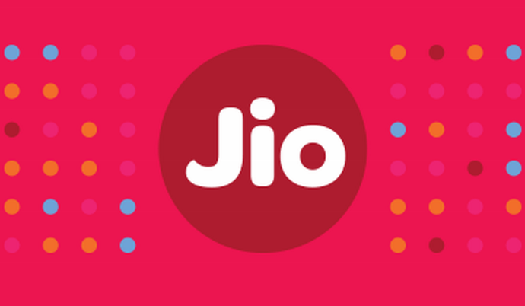

**Organisational Structure-Key**

Jio is owned by Reliance Industries and is headquartered in Mumbai, Maharashtra.

The Key Executives are:

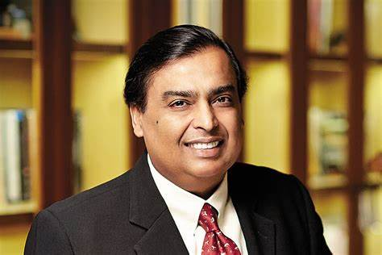

Figure 3.1: Mukesh Ambani: Chairman



Figure 3.2: Pravir Kumar: CEO

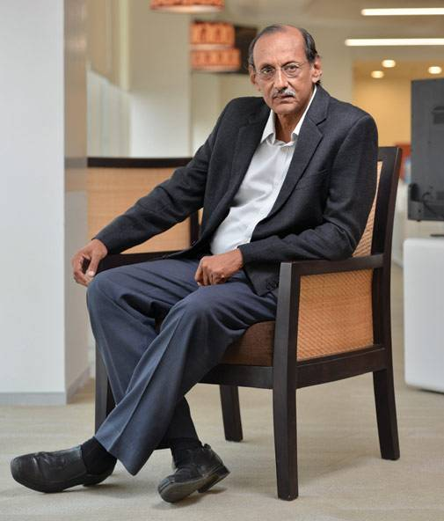

Figure 3.3: Sanjay Mashruwala: Managing Director



Figure 3.4: Rajneesh Jain: CFO



Figure 3.5: Vishal Sampat: Chief Digital Oﬃcer

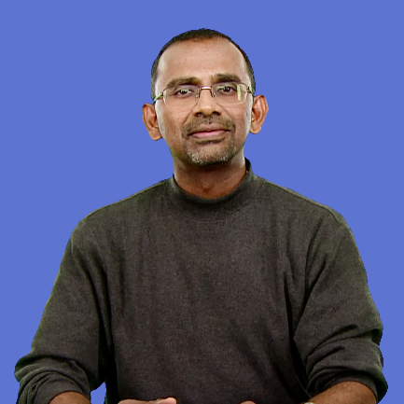

Figure 3.6: Mathew Oommen: President of Network, Global Strategy & Service

Development and Director

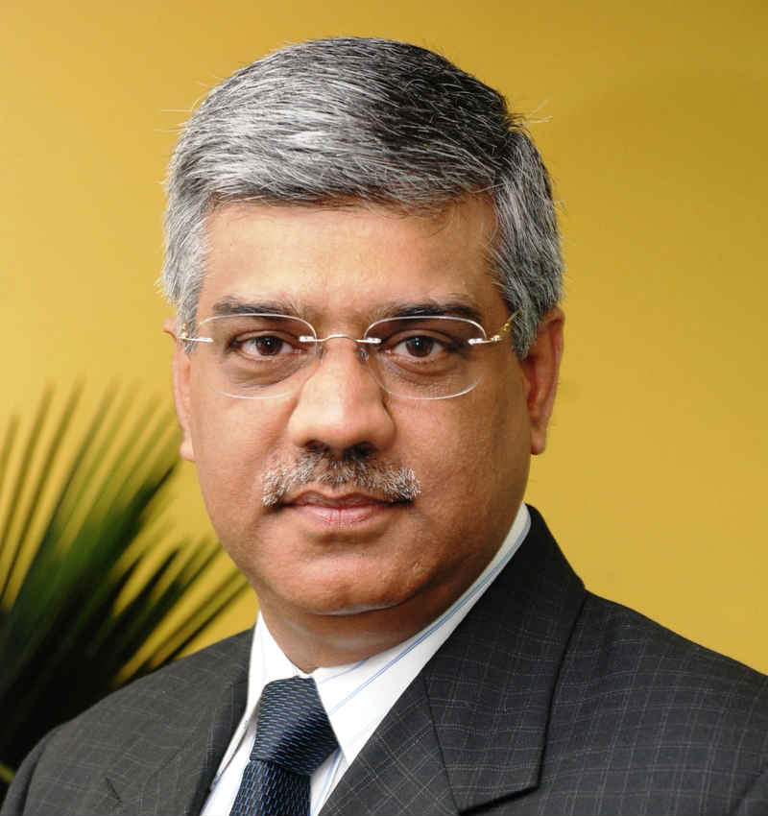

Figure 3.7: Sunil Dutt: President of Devices Business

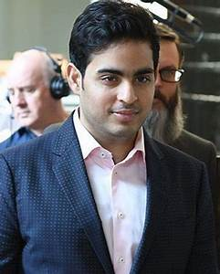

Figure 3.8: Akash M. Ambani: Director



Figure 3.9: Isha M. Ambani : Director

## VISION OF COMPANY

Reliance Jio’s vision for India is that broadband and digital services will no longer be a luxury item. Rather, Reliance Jio envisions an India where these are basic necessities to be consumed in abundance by consumers and small businesses alike, as much in far-flung villages as in our largest cities. The initiatives are truly aligned with the Government of India's ‘Digital India’ vision for our nation.

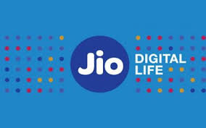

1. **Affordable Devices**: Jio has worked with all the leading device manufacturers of the world to ensure availability of 4G LTE smartphones across all price points – from ultra-premium models on one hand, to entry level models on the other.
2. **Digital Communication**: The application Jio4GVoice brings the 4G communication suite to all smartphones. With its RCS (Rich Communication Services) features like Enriched calling, Chat, File share and Unified Messaging, it redefines the calling and messaging experience. It also enables Jio’s cutting edge voice and video call service on non-VoLTE smartphones.
3. **Digital Currency**: Jio envisions a new India which will use digital currency instead of paper money for a more secure and convenient way to transact. Jio Money, Jio’s digital currency and digital payments business, will play a crucial role in this by offering a platform for ubiquitous, affordable and secure digital payments.
4. **Jio Drive**: Micro and small businesses will soon have access to cutting-edge cloud storage technologies which were once affordable to big companies only, giving them a new edge to compete on a global landscape. Jio Drive is an application that brings powerful cloud capabilities to every smartphone. Using Jio Drive, anyone can store, sync and share any content between their own devices and also with their friends.
5. **Digital Education**: Teachers and students from far flung areas can connect with each other, crowd-source knowledge and adapt new age learning techniques and thus lift the level of education to a completely different plane.
6. **Digital Healthcare**: Expert medical advice would be available anytime, anywhere - with medical practitioners able to grow their practice without constraint, and provide quality of life to the crores that make up our country.
7. **Digital Entertainment and social connectivity**: Jio Chat is a powerful communication application that integrates chat, voice, video calling, conferencing, file sharing, photo sharing and much more. Jio Play enables users to watch HD TV anytime, anywhere on any device, from hundreds of channels, across categories and languages. Jio Beats is a premier digital music streaming service that gives instant access to millions of songs and curated playlists. Jio Mags and Jio News provide access to the most popular collection of magazines and news from leading publishing houses across multiple languages.
8. **Digital Entrepreneurship**: Jio is building is a powerful platform on which a range of rich digital products and services can be enabled - digital currency, digital commerce, digital education, digital healthcare, e-governance, Smart Cities, M2M and the Internet of Things. It does not matter whether these services are created by Jio itself, its ecosystem partners or anyone globally. Reliance is committed to the principles of Net Neutrality.

Laying the Foundation for the Future

* Reliance Jio is creating the most extensive and future-proof network in India, and perhaps, in the world. It will provide next generation legacy-free digital services over an end-to-end all-IP network, which can be seamlessly upgraded even to 5G and beyond. In addition to the existing pan India 2300 MHz spectrum and 1800 MHz in 14 circles, Jio invested over Rs 10,000 crore during this year's auction to acquire 800 MHz spectrum in 10 circles and 1800 MHz spectrum in 6 circles. This brings the cumulative investment in spectrum assets to nearly Rs 34,000 crores. Jio now has the largest footprint of liberalized spectrum in the country, acquired in an extremely cost effective manner.
* Reliance Jio has laid more than 2.5 lakh kilometres of fibre-optic cables, covering 18,000 cities and over one lakh villages, with the aim of covering 100% of the nation’s population by 2018. It has an initial end-to-end capacity to serve in excess of 100 million wireless broadband and 20 million Fibre-to-Home customers. Reliance Jio has also built nearly half-a-million square feet of cloud data centres and a multi-Terabit capacity international network.
* The infrastructure is being built in partnership with some of the world’s most technologically advanced companies.

**VISION OF FOUNDER**

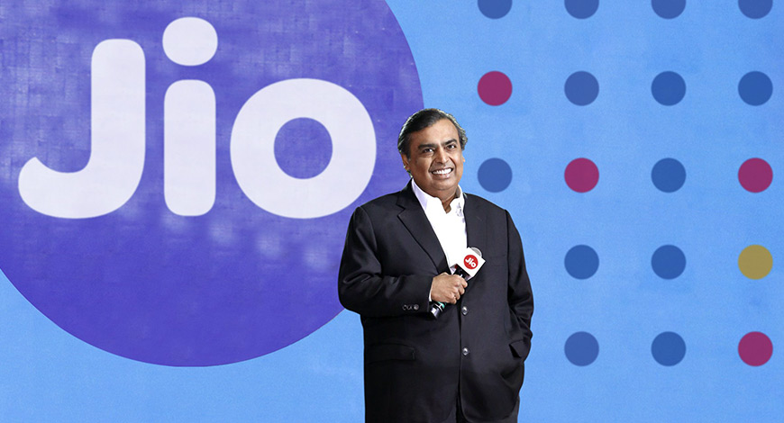

* India will be a fully-4G country and ready for 5G ahead of others. Every phone in India will be a 4G enabled phone and every customer will have access to 4G connectivity.
* At Jio, we are committed to connecting everyone and everything everywhere. Always with the highest quality and the most affordable price.
* To transform the Rural India by bringing Digital Revolution to India’s villages, to agriculture and rural enterprises, to women and to marginalized communities everywhere.The Digital Connectivity Revolution can transform Rural India most comprehensively.
* To begin an ambitious push in fixed broadband through Fiber-to-the-home and premise with JioGigaFibre.
* Jio is committed to building a deep-fibre network across the country and ensuring that every premise is connected with the highest quality network.
* To bring India from a lowly 135th rank to be amongst the top three nations in fixed broadband at a pace that will surprise the world.
* To make the Industry play the role of a catalyst in the mission of propelling our nation towards a bright future. By keeping in mind that data is the most important resource in this new world. And India and Indians will generate humungous amount of data.
* To start the Fourth Industrial Revolution which can realise the Prime Minister’s promise of doubling the incomes of 150 million Indian farmers.
* To realise the AYUSHMAN BHARAT scheme’s promise of bringing health-care to 500 million people ─ the largest health insurance initiative in the world.
* To bring quality education to 200 million students in Indian schools and colleges.
* To create more jobs with the digitally-connected and AI-powered marketplace of small merchants and small enterprises ─ which can be termed NEW COMMERCE for NEW INDIA.

**Mission**

1. To achieve excellence in project execution, quality, reliability, safety and operational efficiency.
2. To consistently enhance our competitiveness and deliver profitable growth.
3. To practice highest standards of corporate governance and be a financially sound company.
4. To be a responsible corporate citizen nurturing human values and concern for society.
5. To improve the lives of local community in all our projects.
6. To be a partner in nation building and contribute towards India’s economic growth.
7. To promote a work culture that fosters learning, individual growth, team spirit and creativity to overcome challenges and attain goals.
8. To encourage ideas, talent and value systems and become the employer of choice.
9. To earn the trust and confidence of all stakeholders, exceeding their expectations.
10. To uphold the guiding principles of trust, integrity and transparency in all aspects of interactions and dealings.

## Company Names and Info

1. **Reliance Capital**

Reliance Capital Limited is an Indian diversified [financial services](https://en.wikipedia.org/wiki/Financial_services) holding company promoted by Reliance Anil Dhirubhai Ambani Group. Reliance Capital, a constituent of Nifty Midcap 50 and MSCI Global Small Cap Index, is a part of the Reliance Group. It is amongst India's leading and most valuable financial services companies in the private sector. As on March 31, 2017, the net worth of the company stood at Rs 16,548 crore, while its total assets as on the date stood at Rs 82,209 crore. In [Fortune India 500](https://en.wikipedia.org/wiki/Fortune_India_500) list of 2018, Reliance Capital was ranked as the **77**th largest corporation in India with 5th rank in 'Non-Banking Finance' category.

Reliance Capital has businesses in [asset management](https://en.wikipedia.org/wiki/Asset_management), [mutual funds](https://en.wikipedia.org/wiki/Mutual_funds), [life insurance](https://en.wikipedia.org/wiki/Life_insurance) and [general insurance](https://en.wikipedia.org/wiki/General_insurance), [commercial finance](https://en.wikipedia.org/wiki/Commercial_finance), home finance, [stock broking](https://en.wikipedia.org/wiki/Stock_broking), [wealth management](https://en.wikipedia.org/wiki/Wealth_management) services, distribution of financial products, [private equity](https://en.wikipedia.org/wiki/Private_equity), asset reconstruction, proprietary investments and other activities in financial services. The company operates across India and has over 20 million customers and workforce of approximately 15, 595 as of May 1, 2017.

[Anil Ambani](https://en.wikipedia.org/wiki/Anil_Ambani), promoter of Reliance Group is the Chairman of Reliance Capital, while Amitabh Jhunjhunwala is the Vice-Chairman and Anmol Ambani as the Executive Director

Reliance Capital Limited was incorporated in 1986 at [Ahmedabad](https://en.wikipedia.org/wiki/Ahmedabad) in [Gujarat](https://en.wikipedia.org/wiki/Gujarat) as Reliance Capital & Finance Trust Limited. The name Reliance Capital came into effect on January 5, 1995.

In 2002, Reliance Capital Ltd shifted its registered office to Jamnagar in Gujarat before it finally moved to [Mumbai](https://en.wikipedia.org/wiki/Mumbai) in [Maharashtra](https://en.wikipedia.org/wiki/Maharashtra), in 2006.

In 2006, Reliance Capital Ventures Limited merged with Reliance Capital. With this merger the shareholder base of Reliance Capital rose from 0.15 million shareholders to 1.3 million.

Reliance Capital entered the capital market with a maiden public issue in 1990 and in subsequent years further tapped the capital market through rights issue and public issues. The equity shares were initially listed on the Ahmedabad Stock Exchange and the Stock Exchange Mumbai. Presently. the shares are listed on the Stock Exchange Mumbai and the National Stock Exchange of India.

In June 2019, auditors of PWC resigned citing that they weren't allowed to carry on their audits of Reliance Capital prevented it from exercising independent judgment in making a report to the members of the company.In a recent development the auditors revealed that the recoverables of Rs. 7083 crore were actually inter corporate deposits of other Reliance group companies that was being diverted. On the other hand Reliance has claimed that there has been no diversion of money; zero loans and or liquidity have been provided by any lender in the PwC audited period. Reliance Capital is confident that the report of the continuing auditor will establish that there were no irregularities.

Operations :

### Reliance Nippon Life Asset Management

Reliance Nippon Life Asset Management (RNAM; formerly Reliance Capital Asset Management Limited) is one of the largest asset manager in India and manages and advises Rs. 3,58,059 crore as per March 2017, across mutual funds, pension funds, managed accounts, alternative investments and offshore funds. RNAM is the only AMC to have the mandate for fund management by EPFO, PFRDA and CMPFO.

RNAM is the asset manager of Reliance Mutual Fund (RMF) Schemes. Sundeep Sikka is the Executive Director and Chief Executive Officer of RNAM.

As per March 2017, RMF manages the highest assets from the ‘beyond Top 15 cities’ category across all AMCs in the industry.

RNAM acts as the advisor for India focused Equity and Fixed Income funds in Japan (launched by Nissay Asset Management) and Korea (Samsung Asset Management). RNAM also manages offshore funds through its subsidiaries in Singapore and Mauritius thereby catering to investors across Asia, the Middle East, the UK, the US, and Europe.

### Reliance Nippon Life Insurance

Reliance Nippon Life Insurance Company is among the leading private sector life insurance companies in India in terms of individual WRP (weighted received premium) and new business WRP. The company is one of the largest non-bank supported private life insurers with over 10 million policy holders, a strong distribution network of over 700 branches and over 75,000 advisors as on March 31, 2017. The company holds one of the top claim settlement ratios in the industry: it stands at 95.21% as of March 31, 2017.

Ashish Vohra is the Executive Director and Chief Executive Officer of RNLI.

In fiscal year 2016, after the enabling regulations, Nippon Life increased its stake in Reliance Life from 26% to 49%, subsequent to the receipt of all regulatory approval. Nippon Life Insurance, also called Nissay, is Japan's largest private life insurer, with 25% market share. The company, with over 29 million policies in Japan, offers a wide range of products, including individual and group life and annuity policies through various distribution channels. It mainly uses face-to-face sales channel for its traditional insurance products. The company primarily operates in Japan, North America, Europe and Asia and is headquartered in Osaka, Japan. It was ranked 114th in Global Fortune 500 firms in 2016.

### Reliance Home Finance

Ravindra Sudhalkar is the CEO and Executive Director of the company.

Reliance Home Finance Limited (RHF), a 100% subsidiary of Reliance Capital, provides home loans, LAP, construction finance, and affordable housing loans. The company has over 1,750 distributors serving over 33,300 customers across 90 locations, through a [hub and spoke](https://en.wikipedia.org/wiki/Hub_and_spoke) model, across the country.

### Reliance Capital's broking and distribution business

[Reliance Securities](https://en.wikipedia.org/wiki/Reliance_Securities), the broking and distribution arm of Reliance Capital, is one of India’s leading retail broking houses. B Gopkumar is the Chief Executive Officer and Executive Director of its broking and distribution business.

The distribution business has approximately 80 branches.

### Reliance Asset Reconstruction

Reliance Asset Reconstruction is an asset reconstruction company, the principal sponsor/shareholder of which is [Reliance Group](https://en.wikipedia.org/wiki/Reliance_Group) (through Reliance Capital). The AUM as on March 31, 2017 stands at Rs. 1,829 crore (previous year: Rs.1488 crore).

1. **Reliance Entertainment**

Reliance forayed into the largely untapped video rental market in India by launching [BIGFlix](https://en.wikipedia.org/wiki/Bigflix" \o "Bigflix).

The company plans to launch TV Channels.

On 15 July 2009, Reliance and [Steven Spielberg](https://en.wikipedia.org/wiki/Steven_Spielberg) announced a joint venture with funding of $825 million.[]](https://en.wikipedia.org/wiki/Reliance_Entertainment#cite_note-5)

Big 92.7 FM launched a radio station in Singapore considering 8% of the population residing there is Indian.

On 5 April 2010, Reliance acquired a 50% stake in [Codemasters](https://en.wikipedia.org/wiki/Codemasters" \o "Codemasters).

On 28 May 2010, the company achieved the first ever Bollywood cross-over into the Hollywood box office market with the release of [*Kites*](https://en.wikipedia.org/wiki/Kites_(film)).

Reliance co-produced director [Steven Spielberg's](https://en.wikipedia.org/wiki/Steven_Spielberg) film [*War Horse*](https://en.wikipedia.org/wiki/War_Horse_(film)), which was released worldwide on Christmas Day in 2011. Many other projects from the director also have the company as a producer. In January 2012, it was announced that Reliance DreamWorks movies garnered 11 Oscar nominations.

In November 2014, the company announced plans to begin the acquisition process of the North American and European mobile game studios of [DreamWorks Studios](https://en.wikipedia.org/wiki/DreamWorks_Studios) in early 2015.

1. **Reliance Power**

**Reliance Power Limited** (R-Power), formerly **Reliance Energy Generation Limited** (REGL) is a part of the [Reliance Anil Dhirubhai Ambani Group](https://en.wikipedia.org/wiki/Reliance_Anil_Dhirubhai_Ambani_Group). It was established to develop, construct, operate and maintain power projects in the Indian and international markets. [Reliance Infrastructure](https://en.wikipedia.org/wiki/Reliance_Infrastructure), an Indian private sector power utility company and the Reliance ADA Group promote Reliance Power.

The company is the sole distributor of electricity to consumers in the suburbs of [Mumbai](https://en.wikipedia.org/wiki/Mumbai). It also runs power generation, transmission and distribution businesses in other parts of [Maharashtra](https://en.wikipedia.org/wiki/Maharashtra), Goa and [Andhra Pradesh](https://en.wikipedia.org/wiki/Andhra_Pradesh). With its subsidiaries, it is developing 13 medium and large-sized power projects with a combined planned installed capacity of 33,480 MW.

[Reliance Natural Resources](https://en.wikipedia.org/wiki/Reliance_Natural_Resources) merged with Reliance Power in 2010, shortly after its [initial public offering](https://en.wikipedia.org/wiki/Initial_public_offering).[[2]](https://en.wikipedia.org/wiki/Reliance_Power#cite_note-reuters020710-2) As of March 2018, Reliance Power has 50 subsidiaries. In [Fortune India 500](https://en.wikipedia.org/wiki/Fortune_India_500) list of 2017, R-Power was ranked as the **124**th largest corporation in India with 9th rank in 'Power sector' category.

Power generation projects :

[](https://en.wikipedia.org/wiki/File:Choudwar_Cuttack.jpg)

Electricity transmission grid in eastern India.

### Coal based Thermal power projects

* [Sasan Ultra Mega Power Project](https://en.wikipedia.org/wiki/Sasan_Ultra_Mega_Power_Project), at Sasan village in [Singrauli district](https://en.wikipedia.org/wiki/Singrauli_district" \o "Singrauli district), [Madhya Pradesh](https://en.wikipedia.org/wiki/Madhya_Pradesh) – 3,960 MW (6×660 MW). Running with full capacity from March 2015. This is designated as an Ultra mega power projects (UMPP) by the government of India.
* [Rosa Thermal Power Project](https://en.wikipedia.org/wiki/Rosa_Thermal_Power_Plant): 1,200 MW (4×300 MW) coal-based thermal power plant in Rosa village, [Shahjahanpur district](https://en.wikipedia.org/wiki/Shahjahanpur_district), [Uttar Pradesh](https://en.wikipedia.org/wiki/Uttar_Pradesh). The plant is fully functional.
* [Butibori Thermal Power Project](https://en.wikipedia.org/wiki/Butibori_Power_Project): 600 MW (2×300 MW), at [Butibori](https://en.wikipedia.org/wiki/Butibori" \o "Butibori) near [Nagpur](https://en.wikipedia.org/wiki/Nagpur), [Maharashtra](https://en.wikipedia.org/wiki/Maharashtra). The plant is fully functional.

### Gas based Thermal power projects

* Samalkot Power Project: 2,400 MW (3 x 800 MW) gas-fired thermal power project at [Samalkot](https://en.wikipedia.org/wiki/Samalkot" \o "Samalkot) in [East Godavari](https://en.wikipedia.org/wiki/East_Godavari) district of [Andhra Pradesh](https://en.wikipedia.org/wiki/Andhra_Pradesh). This partially implemented project is at a standstill for reasons of financial stress and lack of gas supply. Construction is not complete and whatever capacity has been installed is not being used. In 2018, Reliance power signed an agreement with the government of [Bangladesh](https://en.wikipedia.org/wiki/Bangladesh) to "relocate" (or divert?) one unit from Samalkot to that country.

### Shelved thermal power projects

* Tilaiya Ultra Mega Power Project – 4,000 MW at Tilaiya in [Jharkhand](https://en.wikipedia.org/wiki/Jharkhand) - Shelved. Reliance Power exited this project in 2015, citing delays in land acquisition. Three years later, in May 2018, it sold all remaining interests in the project to Jharkhand State Power Development Corporation for a sum of Rs. 112 crores.
* Krishnapatnam Ultra Mega Power Project at [Krishnapatnam](https://en.wikipedia.org/wiki/Krishnapatnam" \o "Krishnapatnam) in [Nellore district](https://en.wikipedia.org/wiki/Nellore_district), [Andhra Pradesh](https://en.wikipedia.org/wiki/Andhra_Pradesh) - 3,960 MW (6×660 MW) - shelved. Shortly after the project was cleared in 2011, Indonesia changed its coal export policy and the project became unviable. Nevertheless, Reliance took possession of the land. In 2016, Reliance began the process of abandoning the project by seeking an exit deal with the [Andhra Pradesh](https://en.wikipedia.org/wiki/Andhra_Pradesh) government. There were issues of money and bank guarantees, and the matter went into litigation. In January 2019, the Delhi High Court upheld invocation of bank guarantees (300 crores) by the government. The project stands shelved.
* Chitrangi Power Project: 3,960 MW (6 x 660 MW) - This coal-based project in Chitrangi in Singhauli district of [Madhya Pradesh](https://en.wikipedia.org/wiki/Madhya_Pradesh) was canceled and shelved even before the agreement was signed. In 2011, Reliance Power won the tendering process by bidding aggressively a price of only 3.70/unit of electricity. However, it made no movement for several years. Resultantly, environment clearance lapsed in 2016 and was not extended. In March 2018, the Uttar Pradesh Power Corporation, which was the customer for the project, canceled the contract and seized the bank guarantees.
* Dhirubhai Ambani Energy City (DAEC) Dadri Power Project in Uttar Pradesh: 7,480 MW (shelved)

### Renewable Energy

There is only one operational Renewable Energy (RE) project. All the rest are pending at various stages; some may have been shelved formally or informally. The projects are:

* [Dhirubhai Ambani Solar Park](https://en.wikipedia.org/wiki/Dhirubhai_Ambani_Solar_Park) – 40 MW. This is the only operational project.

#### Shelved or pending RE projects

* Kalai-2 Power Project: 1,200 MW
* Siyom Power Project: 1,000 MW
* Tato-2 Power Project: 700 MW
* Emini Power Project: 500 MW
* Amulin Power Project: 400 MW
* Urthing Sobla Power Project: 400 MW
* Mihundon Power Project: 400 MW
* Solar Thermal Power project: 125 MW
* PV solar power Project: 40 MW
* Vashi Wind Power Project: 45 MW

(Wind Power – 400 MW, Solar Power – 500 MW and Hydropower – 2,500 MW)

1. **Reliance Communications Ltd:**

Not to be confused with Reliance Jio

**Reliance Communications Limited** (stylised as **RCOM**) was an Indian mobile network provider headquartered in Navi Mumbai that offered voice and 2G and 3G data services. In February 2019, the company filed for bankruptcy as it was unable to sell assets to repay its debt. It has an estimated debt of ₹ 50,000 crore against assets worth ₹18,000 crore.

### As of March 2019, the company has reworked its strategy and continues to operate fixed-line communications, data center services, enterprise solutions as well as subsea cable networks under the banner name, "The *New* Reliance Communications".

Reliance Communications was founded in India on 31 July 2002 as Reliance Infocomm Limited with the introduction of its nationwide [CDMA2000](https://en.wikipedia.org/wiki/CDMA2000) service. It became Reliance Communications Limited in 2006. The company introduced its [GSM](https://en.wikipedia.org/wiki/GSM) service in 2008. It began using [MIMO](https://en.wikipedia.org/wiki/MIMO) technology in 2011 to improve the quality of its 3G service, providing a data rate of up to 28 Mbit/s.

In the 2010 [spectrum auction](https://en.wikipedia.org/wiki/Spectrum_auction), Reliance obtained licenses for 3G spectrum in three cities at a total licensing fee of ₹58,642.9 million. The company reduced the price of its 3G service by 61 percent in May 2012.

Reliance and [Lenovo](https://en.wikipedia.org/wiki/Lenovo) introduced their co-branded [Android](https://en.wikipedia.org/wiki/Android_(operating_system)) smartphones in India in 2013.

The company ended its CDMA operations in 2016, and migrated its subscribers to its GSM and [LTE](https://en.wikipedia.org/wiki/LTE_(telecommunication)) networks by September the same year.

## PRODUCTS

1. **Jio4G voice**

Jio4G voice (earlier JioJoin) from Relience Jio Infocomm Ltd. Now comes in a brand new avatar. Did you know that your regular smartphone is capable of giving you a crystal clear voice and video calling experience? Jio4GVoice enhances your non-VoLTE 4G phone with VoLTE capabilities. You can now use your phone non-VoLTE smart phone to make HD voice and video calls to any landline or mobile number anywhere in the world. You can also use these VoLTE features on your existing 2G/3G smart phones via JioFi.

Not just that, Jio4GVoice also marks the entry of Rich Communication Services (RCS) in India.

RCS has exciting features such as Rich Calls, Chat, Group Chat, file share, location share, doodles, stickers and many more are available.

What Jio4GVoice does?

* Jio4GVoice brings TRUE 4G/VoLTE high-definition voice and video calling on existing 2G, 3G, 4G smartphone.
* It can be used with a Jio SIM either in the phone or in a JioFi connected the phone.
* To turn the mobile device from ‘smart’ to ‘super’ a Jio SIM is needed.. Jio4GVoice will do the rest!
* Rich Communication Experience.

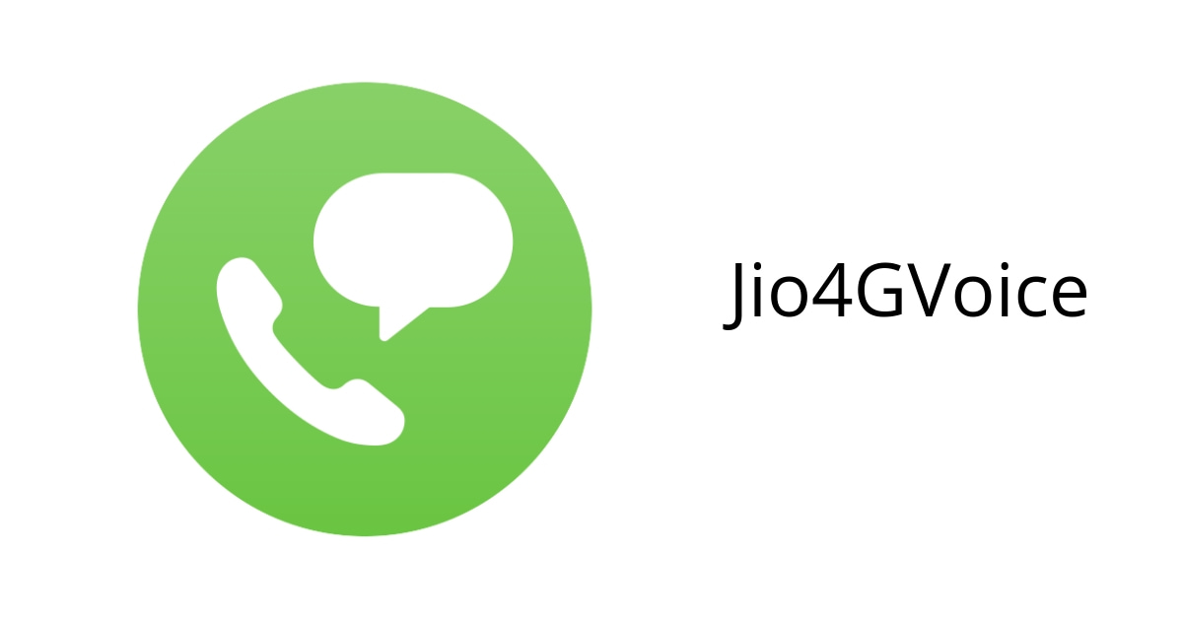

1. **Jio-Fi:**

Product Features

TRUE 4G SPEED :

A state – of -the -art device to enjoy super- fast internet. Enjoy download speed upto 150Mbps and upload speed upto 50Mbps.

4G FEATURES ON 2G/3G SMART PHONES:

Access high speed data and download Jio4GVoice App on your 2G/3G smart phone to make HD voice calls, with Jio SIM Jio-Fi.

VIDEO AND HD VOICE CALLS:

Make Video and HD Voice calls , send SMS and set up even (5+1) Audio & (3+1) Video conference calls with Jio4GVoice app.

CONNECT AND SHARE:

Recommend to connect up to 10 Wi-Fi enabled devices (Smartphone, Lap-tops, Tablets and even Smart TVs ). JioFi allows connecting up to 32 devices.

POWERFUL BATTERY:

Best in class battery (2300mAh) supports up to 6 hours of surf time.

ON THE GO DEVICE:

Sleek and stylish JioFi to stay connected to your digital world, even on the go.

TECHNICAL SPECIFICATIONS- JioFi M2S

No of devices supported: Recommended 10 (Wi-Fi) + 1 (USB tethering)

Standard Compliance: WAN:LTE (2300/1800/850MHz), IEEE 802.11

b/g/n 2.4G only

Power Supply: AC: 100-240V;DC:5V&1A

Dimensions: 85 mm x 55mm x 16mm

External Interface: Micro- SD Card, Micro- USB Port, Nano SIM

Battery Capacity: 2300 mAh

SAR body value: 1.26W/kg

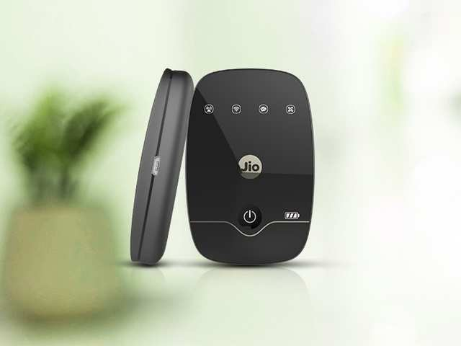

**Jio Entertainment:**

1. **JioMusic**

Provides truly Unlimited Ad-Free access to HD music in your favourite language without any barriers. Listen & Download your favorite HD songs without any additional charges unlike other music apps. Listen it anytime, anywhere. From latest Blooywood songs to hard to find Golden classics, JioMusic comes packed with 1cr+ songs covering across all languages, genres, moods and artists. With a never before True HD quality music (320kbps) and beyond, enjoy a vast catalogue of music library spanning across languages like Hindi, English, Telugu, Tamil, Punjabi, Malayalam, Kannada, Bengali, Gujarati, Bhojpuri, Odiya, Urdu, Assamese, Carnatic, Hindustani and more for all occasions.

+ Comprehensive regional music packaging

+ Download songs and Listen Offline

+1-tourch Ad-Free curated Radio with Unlimited Skips

+ Smart Recommendations

+ High Quality HD music up to 320 Kbps

+Curated Playlists based on Artists, Eras, Moods, Genre etc.

+ Exhaustive Song Playing Options

+Sync downloaded music across devices

+Player Queue: Re- Arrange songs, Create your own player queue

+ No Ads, No Interruptions

+ World’s first: Tap to Play or Tap to Queue options in settings

+ Light and Dark theme options

+ Equalizer – Bring out the DJ in you – By customising listening experience with audio modes (Supports Select Smartphones)

+ Connected devices: Supports Androids Wear, Pebble Watch, Blue Tooth Speaker etc.



1. **Jio Cinema :**

An on demand video streaming app where you can enjoy free Movies, TV shows, Originals, Web series, Short films, Music videos, Trailers, Watch 7000+ blockbusters, 1lac+ TV shows episodes & 70,000 music videos.

Movies can also be downloaded and watch offline at leisure. Can enjoy trending movies preferred languages including Hindi, English, Tamil, Kannada, Marathi, Telugu, Bengali, Gujarati, Bhojpuri, Malayalama, Punjabi, Dubbed content & with subtitles. Kids can also have a fun time with a dedicated JioKids section.

Key Features

* LATEST MOVIE LIBRARY
* BEST OF WEB ORIGINALS
* GRAB YOUR FAVOURITE TV SHOWS
* LATEST MUSIC VIDEOS
* LATEST MOVIE TRAILERS
* KIDS WORLD: JioKids and many more.



1. **Jio TV:**

* Prefferred language support for personalised show recommendations
* Watching can be continued from where left off and also across devices sync.
* Dedicated originals section for original content.
* Favourite section can be chromecasted on big screen.
* Videos can be searched using dedicated search feature.
* Automatic switching features between SD and HD depending upon internet speed.
* Drag and dock feature for watching movies and browsing at the same time.



**Jio Smart Home Solution:**

Reliance Jio introduces some IOT projects that makes your home smart. The Jio GigaFiber launch at RIL was accompanied by the announcement of the Jio smart phone accessories suite. This includes an audio dongle, Video dongle, smart speaker, wifi extender, smart plug, outdoor security camera and a TV camera among others. Alongside major connected devices Jio is set to bring smoke sensor, water leak sensor, gas sensor, siren, panic button, smart video bells and door sensor. These are designed to let users control and monitor their homes using their smart phones. The prime purpose of the new launch is to expand the presence of connected homes in India. With some simple accessories that Jio will provide, every appliance, every plug point, every switch in your house will become smart, which means that they can be securely monitored and controlled from anywhere and everywhere.

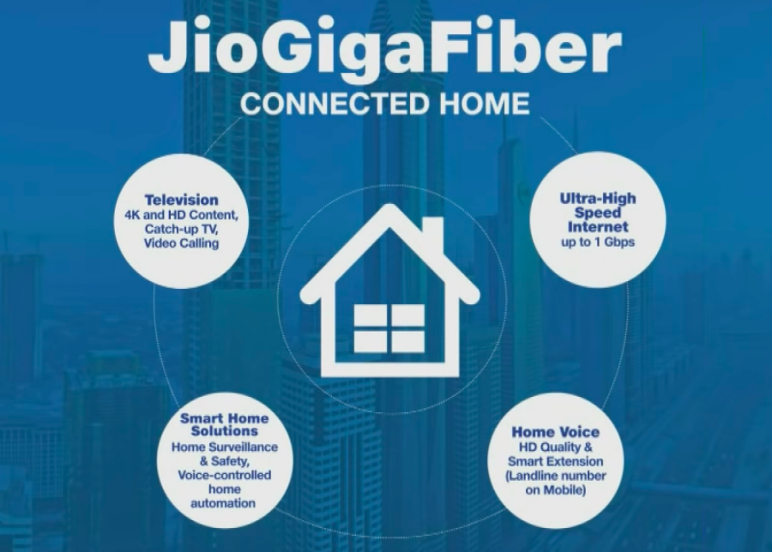

**Jio Car Connect:**

Jio car connect aims to connect 90% of the cars on the Indian roads by year 2020. It’s a combo of hardware device and a mobile app. The OBD (On-board Diagnostic Device) with a jio Sim inside is attached to the ODB port of the car and thus it creates a WiFi spot on the go. It also gives you access to entire eco system of Jio Apps so you can stream your favourite movie or music or TV channel on the go. If you have a Jio Join App installed on your phone using Jio WiFi spot inside your car, you will be able to make voice call free. The Jio Car Connect Mobile app shows you vital car information like oil stats, water level, fuel info, getting alerts to change battery etc. With Jio Car Connect you can switch your car AC when you start walking towards the parking lot. Features like anti- theft alarm, Speed limits setup so if you are lending your car to someone, he drives under controlled speed limits. It also provides you weather information and also let you access your driving pattern.

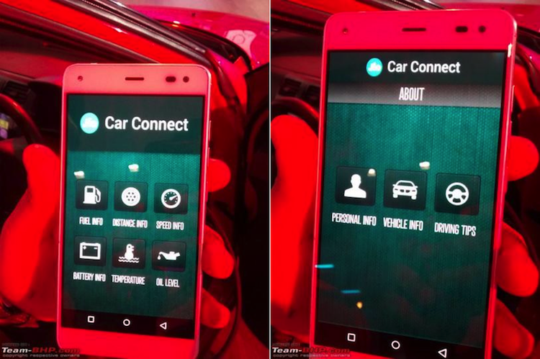

**Jio Merchant App Device:**

While Paytm is trying very hard to get merchants of all sizes and turnovers on its platform, Reliance Jio has launched Jio Merchant App to provide ecosystem for digital transactions. Customers can use there Jio money wallets to pay merchants from their bank accounts directly, and merchant can use the Jio Money Merchant App to accept these payments directly into their bank accounts. This is pretty much what Paytm does too. The Merchant will also be able to transfer money between accounts and make supplier payments through it.

Through this Jio Money merchant app, even small vendors on the street side will be able to accept payments to their bank accounts.

The Jio Money accounts are directly linked to the bank accounts, so the money also gets deposited to these bank accounts.



**Jio School:**

The another beneficial scheme provide by J io for students in educational field is Jio school.

The aim of Jio School is to create maximum numbers of smart schools in most of the Government schools with more efficiency. There will be login Id for teachers from which they will be able to teach the students at 8 to 10 locations with the help of video teaching. The Jio school also supports different vernacular medium school languages which is very helpful to schools eho faces linguistic barriers. Initially it has started in Andhra Pradesh, Madhya Pradesh, Telangana, Gujarat etc. and now it is working for other states. There are 12000 Jio school service started in mentioned states.

**Jio Chat:**

Jio chat provides enhanced messaging, high quality voice & video calls, instant videos, stickers, doodle and emoticons as well as channels from top brands to stay updated and enjoy bite-sized videos on stories.

The features of the app include

1. RICH MESSAGING. Instantly and easily message any of your Jio Chat contacts – one-to-one, or in groups. Send files (e.g. pdf,doc, xls, mp3, apk), emoticons, doodles, pictures, videos, audionotes and 1000s of local Indian stickers while chatting with them. Can create large groups up to 500 members.
2. FREE HD VOICE & VIDEO CALLS. No need to worry about hike in calling tariff because JioChat lets you make free calls to your JioChat contacts. Whether global or local, JioChat delivers both voice calling and video calling with an easy to use interface at no additional charges and as many as users tell us – with far better quality than even PSTN calls or calls on many VoLT apps.
3. MADE IN INDIA STICKERS. JioChat works with some of the most renowned artists in India to create stickers that are fun and help to express emotions in chats with friends, family members and All loved ones. Hindi, Bangla, Kannada, Punjabi, Malayalam, Tamil, Telugu, Gujarati and Odia Stickers.
4. Follow BRANDED CHANNELS. Interact with your favourite brands over chat interface. Send your query and get immediate reply. Get the best deals and customised offers from various channels across categories.
5. Exciting bite sized video STORIES from top media partners in different categories such as food, travel, entertainment, health etc. specially curated for JioChat users.
6. Available in ALL MAJOR INDIAN LANGUAGES. In Hindi, Marathi, Gujarati, Punjabi, Bengali, Kannada, Tamil, Telugu, Malayalam, Bengali & Odia.

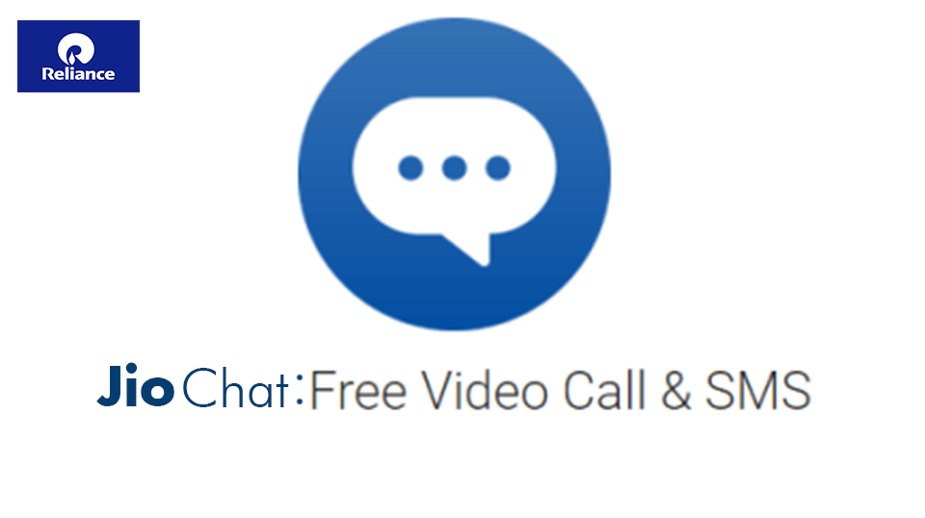

**Jio Health Hub:**

JioHealthHub is one stop solution for your healthcare needs:

* Book Lab Tests & Health Check-ups
* Weight Managements, Diet and Nutrition Consultation
* Read Health Articles
* Manage Medical Reports
* Consult Doctors Online
* Locate nearby pharmacy and blood bank
* Book Lab Tests & Health Check-ups: Book Health Check-ups & lab tests from reputed & quality certified labs. Get samples collected from the comfort of home, access reports on your phone and consult an expert doctor online all for free.
* Weight Management, Diet & Nutrition Consulting. Get consult of an expert to manage weight and personalised diet plans from the top nutritionists and dieticians.
* Genetics Tests: Its ultimately your genes that govern your health! Get advanced genetic tests done and be proactive in predicting your health and disease status.
* Medical Reports

Scan upload and manage all your medical records (lab reports, prescription, medical bills etc.) and securely share them with doctor, family and friends with ease.

Data is stored in the cloud which is accessible from anywhere, any time with secure credentials.

* Consult Doctors online

Consulting doctor’s privately over chat, call and video from Jio HealthHub and get health queries answered at convenience.

* Locate nearby Pharmacies and blood banks.

Find nearby Pharmacies, blood banks and their contact details.

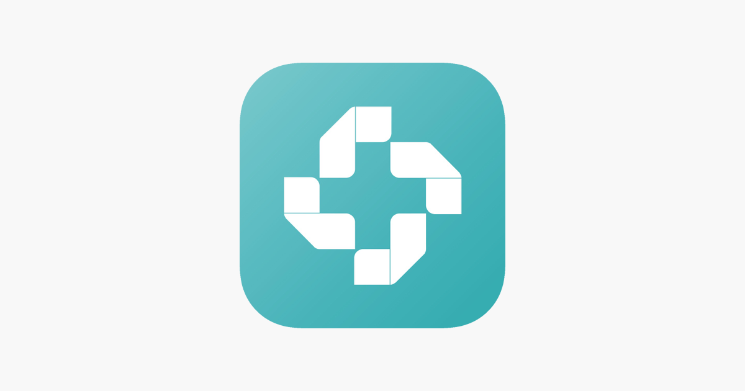

## JIO BROADBAND SERVICES

**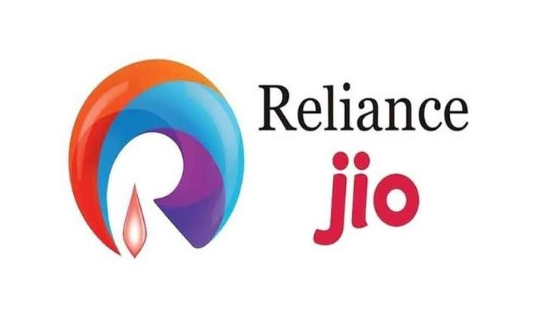**

Reliance Jio has doubled its customer base since the last Reliance AGM. It has now crossed the 215 million mark within the 22 months of its initiation, a gigantic feat that no other technology company has achieved till date, as per Reliance.

Reliance Jio **data usage** has grown from **125 crore GBs** per month to **more than 240 crore GBs** per month.

Jio has widened the gap between itself and its competitors as the **world's largest mobile data network**, a position it had achieved last year.

**Voice usage** on the network has grown from **250 crore minutes** per day to more than **530 crore minutes** per day.

The amount of **video consumption** has grown from **165 crore hours** per month to more than **340 crore hours** per month.

Customers are actively engaged with Reliance Jio for more than **290 minutes** per day on an average.

On track towards achieving a target of **99% population coverage** with 4G-LTE.

Jio has **doubled its Network Capacity** over the past 12 months.

Even after serving the 215 plus million customers, the **capacity utilization** of the Jio network is **less than 20 percent**. Which means, that Jio can multiply its customer base without additional investment.

**Fastest network in India** as attested by the TRAI speed-test data for each and every month of the past year.

A total of **25 million JioPhone users** in India.

Reliance Jio is the India's first LTE-only network, which means that users don't have to worry about the network dropping to 2G or 3G. Other telecoms are now pushing hard for their 4G services and at times Airtel also drops to 3G or 2G when there is no network coverage, which is a bit of underwhelming.

The company launched its 4G broadband services throughout India in September 2016. It was slated to release in December 2015 after some reports said that the company was waiting to receive final permits from the government. Jio offers fourth-generation (4G) data and voice services, along with peripheral services like instant messaging and streaming movies and music.

The company has a network of more than 250,000 km of fiber optic cables in the country, over which it will be partnering with local cable operators to get broader connectivity for its broadband services. With its multi-service operator (MSO) licence, Jio will also serve as a TV channel distributor and will offer television-on-demand on its network.a unit of [Reliance Jio Infocomm Ltd](https://www.livemint.com/Search/Link/Keyword/Reliance%20Jio%20Infocomm%20Ltd) (R-Jio), has got a provisional licence to operate as a pan-India multi-system operator (MSO), taking it a step closer to becoming a nationwide distributor of television channels.

Reliance Jio Media had applied for a pan-India MSO license in January with the intention of using its fibre-to-the-home (FTTH) connectivity to offer a host of services to its prospective customers, including television channels, high-speed Internet, telephone and wireless access.

There are 170 million-odd television sets in India. Of these, 20 million are terrestrial (Doordarshan), 40-45 million are connected through direct-to-home (DTH), and around 100 million have cable television connections—out of which 30-35 million are digitized. So, effectively, R-Jio will be vying with the existing MSOs and DTH companies, said [Sisir Pillai](https://www.livemint.com/Search/Link/Keyword/Sisir%20Pillai), chief strategy officer of Digi Cable.

Jio Fiber is a fibre-to-the-home internet broadband service provided by telecom operator Reliance Jio Infocomm, part of the Mukesh Ambani-controlled Reliance group. The service was first announced as Jio GigaFiber in 2018 at the Reliance Industries 41st annual general meeting. Later renamed Jio Fiber, it is scheduled for a commercial launch on September 5, 2019.

The Jio Fiber service is currently under trials at select locations in several cities and states. The FTTH broadband service promises a speed of up to 1 Gigabit pert second. Besides, it would be the core technology enabler behind the GigaTV platform and the company’s products in the internet of thing (IoT) ecosystem.

Currently, the Jio Fiber broadband service is offered at select locations across the country under the company’s preview offer. In the preview offer, the broadband service is provided by the company without any cost. But, to obtain the connection, a user needs to deposit a refundable security deposit of Rs 4,500 for a 100Mbps and Rs 2,500 for 50Mbps connection. Though there is no deadline for the preview offer, it is expected to end soon after the commercial launch.

Though the company is yet to unveil Jio Fiber plans, Ambani announced at Reliance Industries’ 42nd annual general meeting that the Jio Fiber base plan with a 100Mbps speed would start at Rs 700. The company also shared its plans to launch ‘Jio forever’ data plans, in which a free 4K LED television will be bundled with a Jio Fiber connection set-top box.

The bundled set-top box would be capable of streaming 4K resolution content. It will also support console-like gaming with support for external joysticks and controllers. It will have a provision to make video calls and also be capable of providing mixed reality experience for shopping, education, etc. Besides content from other platforms, the set-top box would come with a built-in suite for Jio apps, for entertainment, educations, cloud services, etc.

## Jio Cloud Services:

Reliance Jio on Monday announced the launch of its connectivity and cloud infrastructure services, especially for start-ups and micro, small and medium businesses. While these services will be free for emerging start-ups, MSMEs can avail of these services starting from Rs 1,500 per month.

Reliance Industries chairman [Mukesh Ambani](http://www.financialexpress.com/tag/mukesh-ambani/) said 80% of the cost of running a start-up goes towards cloud and connectivity infrastructure. “Jio will invest and financially support those start-ups that have the potential to address India’s big needs in agriculture, healthcare, education and skill development which will boost creation of new livelihoods,” he said.

Talking about small businesses, Ambani said a bundle of connectivity, productivity and automation tools now costs a micro and small business between Rs 15,000 and Rs 20,000 per month.

However, Jio aims to provide small businesses with unlimited enterprise-grade voice and data services, video conferencing solutions, marketing and sales solutions. “These tools will help them run their business efficiently and at par with larger enterprises,” said Ambani.

**Jio Cloud**



Reliance Jio has updated the MyJio app to bring Jio Cloud integration. The cloud access lets users store their photos, documents, and media content directly using the MyJio app. A standalone Jio Cloud app is also available for both Android and iOS devices. There is a Web version of Jio Cloud, too. However, the latest integration would help Reliance Jio expand the base of its cloud offering. The updated MyJio app also allows users to set, deactivate, or listen to the available Jio Tunes.

The updated [MyJio app](https://gadgets.ndtv.com/tags/myjio-app" \t "_self) for [Android](https://gadgets.ndtv.com/android) and [iOS](https://gadgets.ndtv.com/tags/ios) devices brings a dedicated Jio Cloud section. The new development is aimed to let users easily back up their photos, videos, documents, and media content using the MyJio app.

Once backed up, the data stored on Jio Cloud can be accessed from any Android or iOS mobile device or through the Web. Users can also manage the settings for storing backups or change the backup file type or network preference directly through the Settings menu available on the MyJio app. Moreover, the app shows a bar to reflect the remaining storage available on the cloud.

Android users can download the updated MyJio app (version 5.0.27) by visiting [Google Play](https://play.google.com/store/apps/details?id=com.jio.myjio&hl=en_IN), while iOS users need to visit the [App Store](https://apps.apple.com/in/app/myjio-for-everything-jio/id1074964262) to download its latest version (5.0.11). The app is compatible with devices running at least Android 4.4 or iOS 9.0.

## BUSINESS MODEL OF RELIANCE JIO

**Reliance Jio 4G is more than being a mobile network. It is Mukesh Ambani’s largest bet ever on various domains - 3 to be precise - mobile network, digital services, hardware sales.**

**The Indian telecom market - basic facts**

* There are 100 crores mobile subscriptions in India (1 billion)[[1]](https://www.quora.com/What-is-the-business-model-of-Reliance-Jio-How-are-they-offering-4G-data-at-such-cheap-rates-How-are-they-providing-unlimited-voice-calls-free-to-every-Jio-customer-How-are-they-offering-unlimited-4G-data-at-night#ACLlM).
* However, only 34% of India’s population is connected to internet[[2]](https://www.quora.com/What-is-the-business-model-of-Reliance-Jio-How-are-they-offering-4G-data-at-such-cheap-rates-How-are-they-providing-unlimited-voice-calls-free-to-every-Jio-customer-How-are-they-offering-unlimited-4G-data-at-night#tzaHx)
* Among those using mobile phones, only 10% use 3G data or above[[3]](https://www.quora.com/What-is-the-business-model-of-Reliance-Jio-How-are-they-offering-4G-data-at-such-cheap-rates-How-are-they-providing-unlimited-voice-calls-free-to-every-Jio-customer-How-are-they-offering-unlimited-4G-data-at-night#aUmKa)

Business model of jio is plain and simple. They are here to make profit and add it to the overall balancesheet of RIL. Telecom ops in a country such vast requires capital expenditure on active and passive infra buildup. With jio , the tides are in their favor because at the time of their maiden entry through Reliance Infocomm in 2003, they had the benefit of 850 mhz offering, which had best network propogation. It means that they could provide same coverage with half the number of BTS (Towers) than any other operator who had its services on 1800 mhz band.This time, their prized possession in their ofc network along with the huge huge spectrum holding they have. I do at times think that what if TRAI today removes the Spectrum Holding caps in accordance with Competition Commission of India.

If you were a telecom company, you would realise that there isn’t going to be a lot of movement in voice now. This is because almost all people have mobile phones. So, Basically The focus just got shifted to data now, from voice that ruled the last decade. So the big challenge is internet. Future lies in using data on your mobile phones. Hence, the smartest move now is to invest into building your infrastructure for the future.

Here is why nothing else matters -

1. When you have data, you don’t care about messaging. Who really uses SMS after the advent of Whatsapp and other such applications?
2. If the internet speed is reliable, will you not switch to Whatsapp calls, or calling over internet in general? Who cares about the voice network at all?

*If any company manages to capture the data penetration in India, they virtually own the telecom sector in the entire country.*

Reliance Jio is currently the most suitable contender in the race.

With the advent of tech, one IP Network can cater everything that other operators can, but with less load of equipment and retro tech. They started from scratch after pseudo bidding through HFCL, and build Nation’s second largest optical fiber . Reliance Jio invested ₹ 150,000 Crores ($ 22 billion) into this fibre optic network.[[5]](https://www.quora.com/What-is-the-business-model-of-Reliance-Jio-How-are-they-offering-4G-data-at-such-cheap-rates-How-are-they-providing-unlimited-voice-calls-free-to-every-Jio-customer-How-are-they-offering-unlimited-4G-data-at-night#aStQi)Now, if you are investing such a huge sum of money into the market - 4G market - which is still untested in India, how are you expecting to earn profit? In other words, how exactly will they get back those ₹ 150,000 Crores?

What they are doing now is identifying who all are low and high ARPU (AVERAGE REVENUE PER USER) customer, apart from reading usage trends offering unlimited services till 31st. Their net velocity app can provide exact coordinates to RF teams for optimizing network. When they launched CDMA, in 2003, the issue was of handsets. For that this time too they have come up with dirt cheap sets , which will support all the 3 bands, that they operate on.  
Also, they’d be bidding for additional spectrum in come circles and basic spectrum in few bands in a few circle. For example, in Bihar circle, they have no spectrum in 1800 mhz band , so they are definitely going to bid for atleast 5 mhz in bihar circle, this Dhanteras.

The govt is soon going to make ip calls free,just the way they removed any charges from LandLines, and this the reason for bsnl landlaine provide ul calls on sundays, Though they can provide it everyday. They already tweaked UASL LICENCE norms to allow operators such as jio to provide VoLTE , as the licencing norms earlier, in the telegraph act only spoke of circuit switch calls or conventional calls.

Last but not the least, they have an undersea cable that they own with 3 other global carriers jointly , which connects India to south asia and beyond. Till now, only the trio of Rcom of Anil, Tata Comm and Airtel owned them, and everybody leased bulk data from them.

A brouhaha always settles down, but you can be assured that from today onwards, there’d be two camps. One of hoodwinking airtel,voda, idea and one camp of rest all operators. Though the tele industry has already marched towards consolidation , with mergers and acquisitions on horizon. If a three way probable merger happens between aircel-mts-rcom and Rjio, that will have long lasting effects.

Its also the time for the govt to think, whether to go with the idea of Socialism of 70s and continue having an state-owned carrier , if yes, then what should be the policy?  
Bsnl already has a tie with JIO for BTS sharing and 2G 3G FALL BACK,wherever 4G is not present, and to provide the combo of 2 networks in one.  
Shouldnt we think of either Disinvesting or forging ties with other operators too , so that the nation doesnt have to fund its plunging .

**THE RELIANCE JIO MASTER PLAN:**

This is actually a very calculated risk that they are taking. Here is the approach:

1. Step one - Undercut the market price by giving attractive discounts
2. Step two - Let everyone switch to Jio for internet use at cheap rates
3. Step three - Unleash the power of fibre optic network to give super fast internet
4. Step four: Grow your subscriber base
5. Step five: Recover your investment using the large number of users

Once you have already laid down the fibre optic network, the cost of operating it is not very huge. On the contrary, you can operate the network at minimal cost. Therefore, the only focus is to get more internet users.

If you look at the tariff plan[[7]](https://www.quora.com/What-is-the-business-model-of-Reliance-Jio-How-are-they-offering-4G-data-at-such-cheap-rates-How-are-they-providing-unlimited-voice-calls-free-to-every-Jio-customer-How-are-they-offering-unlimited-4G-data-at-night#XVrua), you will notice that it conforms to the above ideology. They are not charging for the voice calls because they don’t care about voice. In fact, not charging for voice will attract more people towards Jio. After that, they can showcase their data capability.

Their network is capable enough to handle amazing internet speeds. It therefore encourages the users to use internet instead.

What happens when you get hooked on to mobile internet? You basically kill the entire market of your competitors. This is because you have rendered them completely useless (recall that with good data, you don’t need SMS and phonecalls - everything can be done through internet).

**How many subscribers do they need?**

They are charging about ₹ 70 per GB of data. Let us assume that their contribution (profit before fixed cost) is ₹ 50 per GB of data. (Even this is on the lower side; per GB cost is actually going to be lesser).

If you do the math, you will be able to realise that **if 30% of people in India use 2 GB internet per month, then he can recover the initial investment in 3 years**.

Actually, Mukesh Ambani thinks he can capture 90% of the country by next year. [[8]](https://www.quora.com/What-is-the-business-model-of-Reliance-Jio-How-are-they-offering-4G-data-at-such-cheap-rates-How-are-they-providing-unlimited-voice-calls-free-to-every-Jio-customer-How-are-they-offering-unlimited-4G-data-at-night#YzCrO)

So, my calculations are actually quite conservative on that front.

Yes, it is possible that they earn money out of this.

**Mukesh Ambani’s biggest bet**

The whole master plan is based on **one single thing**: volume.

Right now, they just need the numbers. If they can manage the numbers, as high as possible, they will pull it through. Can they manage to increase the subscribers?

Considering the technological backbone and the cheap data prices, the correct question to ask is - *why not?*

**WHY DID RELIANCE AS A STARTUP WORK SO WELL:**

1. In 2010, **non-compete agreement was expired**, Mukesh Ambani bought 95% stake in Infotel Broadband which had won 4G spectrum in all sectors in India. Then JIO Took birth with Small Entity RANCORE.

2. **Total 06 Years of Preparation** to build huge network, Network is not build in legacy Network. It’s all New Technology which involved Research work RANCORE Network (Reliance owned Co.), NOKIA, CISCO, TECH MAHINDRA, Mahindra COMVIVA , IBM etc.. You Name Pioneer it worked for JIO In last 06 Years. In Nutshell Its not Copy work It was Full Research.

3. Despite Tough Competition Reliance(RIL-MDA Lead) entered into Telecom because they understood that**Telecom is lucrative business in India**. As huge number of potential Subscriber base was there which was still unhappy with data speed by current operator. Mukesh Ambani knew that they could compete in war because they have their own Backbone network i.e . 2.7 Lakh KMs of Optical fiber network in India. This Fiber network Heritage asset to RIL and proved boon for this revolution.

4. **Big data Analytics’** - with this launch, they will have access to tremendous data, closest to Government’s database of AADHAR cards.. You must have read E-Aadhar ID will help you connection activation in 15 Minute. Imagine they will have access of 100 Crore AADHAR IDs in few years. And this **data is literally precious. Can become Alladin lamp**).

5. You will become identified probable consumer for all RIL Business lines. Like Reliance Retail, Digital, Petrochemical, Rel FBB etc…

6. **Being owners of Indian Internet Subscriber they can play big by collaborating with giants like Facebook or Google**, Microsoft CISCO. Income Potientail is there in **Digital Adervsting**

**HOW DOES JIO MAKE MONEY:**

**High Usage , Cheap Tariff and focus of Increased ARPU**

Very First thing for Quora readers Jio is not in market to make charity in the name Digital India or blabla.

They are here for capturing 1.3 billion customer and shelling money out of there pocket . Their tariff plans may look unbelievably overwhelming, but they will make more money by giving free voice calls than what the other companies make by charging you for it!*.*

JIO is targeting to Increase Internet Penetration which is currently 34 % Only. (for 3G only 10%.

**ARPU- Increase ARPU to Money**

This is simple game of ARPU (average revenue per user) .

Current network providers get is around Rs 122-132 per month from user.

Minimum Plan Jio is offering Rs 150. Minimum ARPU of Reliance JIO will be far better than other operators. ( Just make average of 150\*A+500\*B+1000\*C+1500\*D+ ….). ABCD are Number of subscriber in millions)

Now Question why Customer will buy 500 Rs , 1000 Rs data Plan.

Britisher gave free Tea to Indians. Indian left drinking milk and started tea and today we all know much tea India consume.

**Habit**:-Similarly JIO will offer Free data via Preview offer Customer will Develop habit of consuming more data and when speed will be above 20Mbps data will be consumed at higher rate and you will not bother about it . And at the end you will forced to buy higher rental plans worth rs 500 and 1000 atleast.

Belive me once you use data in 4G( VO-LTE). You will never turn back to 3G or LTE network of other operator. E.g After Qwning & Driving Honda City you will never buy Maruti 800.

**Need/necessity**:-New technology Platforms and Digital Environment will force you buy ample data from any Telecom player. E.g today you cant imagine school study with internet.

The Rs 500 plan is significantly higher than the industry ARPU of around Rs 132

Another Catch is Pay 13 Month bill in one year. (365/28 Days= 13). This is somehow every operator has started following to increase revenue . Thanks MBAs behind this 28 game numbers

**Technology Support & High Speed :**Since Jio Is pure 4G network. JIO SIM will work only on SIM Slot 1 ( Primary SIM). Usually 2nd SIM are 2G only. This Configuration will Enhance there Business. User will use Data From JIO only. Since Calls are Free in JIO So User will never use 2nd SIM. That SIM will be used only for Incoming or When VOLTE Signal in not available.

So I Guess readers are now aware who will be paying money in RIL Piggy bank.

**1GB costs for JIO user/Subscriber?**

If we exclude the unlimited night data and the wifi data which many of us may not have access to, then the price per GB of these plans will be

0.3GB for Rs149 = ~Rs 497/GB (who will buy this ?- 300 MB pack)  
 4GB for Rs 499 = ~Rs 125/GB (Cheaper Than Any Indian Mobile Operator)  
 10GB for Rs 999= ~Rs 100/GB ( -do-)

20GB for Rs 1499= ~Rs75/GB (-do-)  
 35GB for Rs 2499= ~Rs71/GB ( Cheaper than Fixed BB, )  
 60GB for Rs3999= ~Rs66/GB –do-  
 75GB for Rs 4999= ~Rs66/GB –do-

So don’t get trap of Rs 50 /GB. That is only applicable if you use only Data 5 Paisa/MB

**Why night Data is Free**. and Calls are free.

Being a Telecom Professional i tell you truth behind this.

**Night Data:-**All Servers keep on running 24 \*7. No matter Consumer is there or not it severs consume only electricity. Since fiber Network is yours then you don’t have to pay any other charges to anyone for data.Thats why they can offer free unlimited free data to few night owls( User) . That’s another Marketing catch . WIN WIN scenario for telco and user .During night time usage is very very less. it will congest the network.

And, the unlimited night usage is only valid for hours in-between 2AM and 5AM only

Free Calls : When you have Data pack .Have you ever paid for Whats app call , Line of skype. Answer is “No” . Its all IP network No Minute base concept is here. Just JIO has to bother about termination call charges in another network which it fetch out from ARPU.Same is applicable for free SMS.

"In a worst-case scenario, this might imply Bharti's voice ARPUs falling by as much as 50 per cent at the higher end of the subscriber base if it were to match Jio," says Sharma. Airtel's voice ARPU is currently at Rs 156.

**JIO will also make money from LYF Handset:-**

History Repeat. This time also RIL has imported very Cost Chinese handset from China which are obsolete for global market. Those handset are again produced at very very low profit margins. That’s seems to cheap. Customer will buy those because of special plan for lyf Handset user.

Again for JIO welcome Preview offer JIO SIM will be given in priority to LYF handset Set buyer. This Strategy will increase sales of LYF handset. As per report of Jun 2016.

**Reliance LYF becomes the third largest 4G smartphone vendor in India: CMR( June 2016 Report)**In the mobile phones segment, Samsung, Lenovo and Reliance Industries’s LYF are the three leaders with 32 per cent, 14 per cent and 13 per cent market shares, respectively.

**Income From Other Sources** :-Not detailing about revenue from App ecosystem(they created app like whatapp paytm sportv ), FTTH, wireless Dongle, Enterprise lease line, IPTV etc..

## MARKETING STRATERGY

Anecdote here: There was a rice wholesaler in Bangalore in the 70s who sold rice cheaper than everybody else, and at a rate considered impossible by others, and even competitors started buying from him sometimes!

The same questions came up then - How does he do it? How can he do it? What is his business model (not quite the same term then)?

Nobody figured it out until he was the biggest player, making zero profit on the rice but becoming rich, with phenomenal growth, with the biggest market share. All kinds of theories floated about. Then it came out. He was selling hundreds of thousands of gunny bags, which he ensured came back to him from the previous lot, when he supplied the new stock of rice to everyone below him in the supply chain! He could not care less about the price of rice because he sold it at the price he got. Because of volumes, he could of course procure from anywhere at the lowest price too!

Jio is not a phone or data service, people!

It is a platform for a bouquet of services that include shopping, travel, entertainment, education, food, banking, you name it! These are all to be rolled out one after another, and in the habit of consuming data without hesitation, if you buy more data, so be it. We all know the rollout has long since started. Jio stands to make substantially from all of these offerings, in the long run.

For the captive audience needed, what better way than to capture a large number of consumers in one shot? That was the draw, the groundbreaking offer of free data,

How many of you are using a smart phone worth more than 10000 rupees now?

Do you remember what is the phone you were using 10 years back? Do you remember its cost? I am sure it is much less than the cost of the phone you are using now. Before smart phones became part of our lives, cost of the phones was almost stagnant in their respective segments.

But people started to pay more for phones now because we are able to do much more with our phones than before. Please starts to pay more when you get REALLY more. Industry said **Pay more for more comfort.**Your own behavior in this field reveals the customer behavior.

Now, think about your ISP connection. I was paying 300 rupees a month for 300kbps few years back. Then upgraded to 1MBPS for 450 rupees. Now using 10MBPS at 650 rupees. So what changed? I am shedding more money for faster speeds(comfort).

Same principle here.

Jio wants to revolutionize the data market. Moreover, they want to penetrate the market aggressively. Imagine, what will happen if almost everyone is using data. With a smartphone and a data connection, what will everyone do? Most of us will have whatsapp/viber or some other app that helps us do free calls. If you are using a 4G network, will you ever like to make a normal call to your friend when you can talk for free on such apps?

Then what is the point to bill normal calls? In addition to this, Jio is using data lines(voice over LTE) for calls unlike other networks who use hybrid lines.

In case of Reliance Jio, the data and voice call remain on the same network. In other words, you are making data-based calls, for which Reliance Jio is charging you a sum.

Check the basic plan. For a month, it costs 149 rupees. You will get free voice calls and 300MB data. Here **300MB data** is what the company is looking at and **free calls** is what we, customers are looking at.

Presently, Those who are not willing to use data plan as they have wifi network at home and a prepaid/postpaid balance will rethink. ARPU is 169 at present. So let us consider that a normal person spends Rs 100 on voice calls. He will think to upgrade to 149 plan as he gets free voice calls and data of 300MB 4G.

It is 4G network. Most of the users cannot stop themselves from limiting themselves to 300MB in 4G. Even if 30% of the users wanted to upgraded to second plan, that is 500, then it significantly increases the ARPU(Average Revenue Per User).

***This is what I call thinking Hatke..!! Technology is Improved and adapting to technology is the sole business model here.***

“These users have never used Google, YouTube, Netflix or even Whatsapp,” says Kunal Bajaj, angel investor and independent telecom consultant. For everything Jio has an app, be it health, news, magazines, television, movies, music, connected car, chat, ecommerce or mobile payments.

“It’s like China, where there is a huge dominance of local brands in the internet business. Once these first-time users take the Reliance Jio connection of the bundled phone, they might end up consuming services on Jio’s apps,” Bajaj added. Rather than heading out to others.

With its free offering, Jio managed to gather a pool of customers from both the small and incumbent players, which is now a critical user base. “It is like a walled garden,” says the executive with the competing telecom operator. “They are hoping that all the users will stay inside the Reliance ecosystem.”

If Ambani pulls this off, Reliance Jio will be the first telecom operator to be a successful content company. It won’t have any local or international equivalent. The content business is ruled by companies such Google, Facebook, Netflix, Hostar, among others, which Reliance Jio will have to compete with.

**The marketing strategy of Reliance Jio is**[**proof**](https://www.slangbusters.com/)**enough that many of the existing customers of other market players will switch to Jio and its supposed pricing will help it boost its profits for the company and also save the customers' money.**It is expected to recover its very big capital investment in a few years ahead.

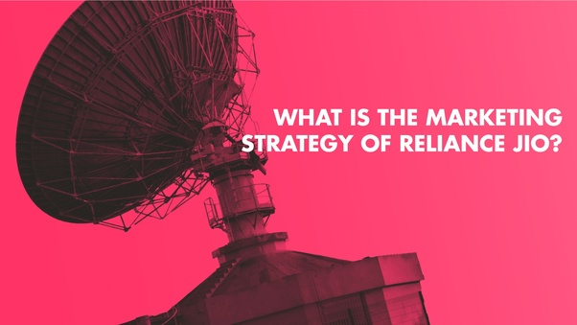

**The marketing strategy of Reliance Jio can be summed up in five distinct stages:**

**ACQUISITION:**

As discussed above, Reliance Jio has acquired or rather captured the market by providing “everything for free”. Free data, voice calling, video, music, content, roaming and a bouquet of applications and even free SIMs. Each ID proof can buy 8 Jio SIMs absolutely free.

**ACTIVATION:**

Reliance Jio is 100% VoLTE (Voice over LTE) network. It means we make voice calls on the data network. It implies voice service is transferred as data flows inside LTE data bearer. VoLTE enabled Jio SIM is activated in a day.

**REFERRAL:**

Before customers started buying Reliance Jio SIMs, one hardly saw any advertisement of the brand on TV, radio, newspapers etc. There seemed to be no promotional activities for Reliance Jio, no brand ambassador, no approaching celebrities to help sell their product.

**CONCLUSION:**

Business is called successful when it brings success and profit to all the parties involved. Reliance Jio has done a fair job at this both customers and marketers use

**This created a very strong brand image and created great loyalty towards them. This was greatly achieved due to the special marketing strategy used by the Reliance Jio. The Reliance Jio knocked down all the other telecom industry which created a**[**greater**](https://www.slangbusters.com/)**loss for the other telecom industry. Reliance Jio gave**

## BUSINESS ANALYSIS

Ambani is betting on a large number of data users. Costs will be driven down with economies of scale. “Based on the assumption that he will have an unprecedented scale, he has already lowered his price… He is asking users to pay the amount he would charge with two to three times of Reliance Jio’s current scale,” the expert says.

Jio’s growth is funded by the money Reliance Industries makes from other businesses, especially its cash cow energy business. Downstream chemical margins and oil prices, which have outperformed Asian gas prices, have made it comfortable for Reliance to pump in money into Jio.

The executive with the incumbent telecom operator says, “Eventually the oil business will go down. Look at the signs – automobiles is moving towards electric vehicles… What will Reliance’s new business be? That is why Mukesh Ambani is creating an alternate business in telecom.”

Globally, experts believe “[data is the new oil](https://www.wired.com/insights/2014/07/data-new-oil-digital-economy/)”. Ambani’s presence in oil is bankrolling his data play. “We see the potential for 2017-18 earnings to rise by 3% more than offsetting the impact from the free telecom offer,” writes Parag Gupta of Morgan Stanley in his research report on the company ‘Monetization – Steady but Slow’.

[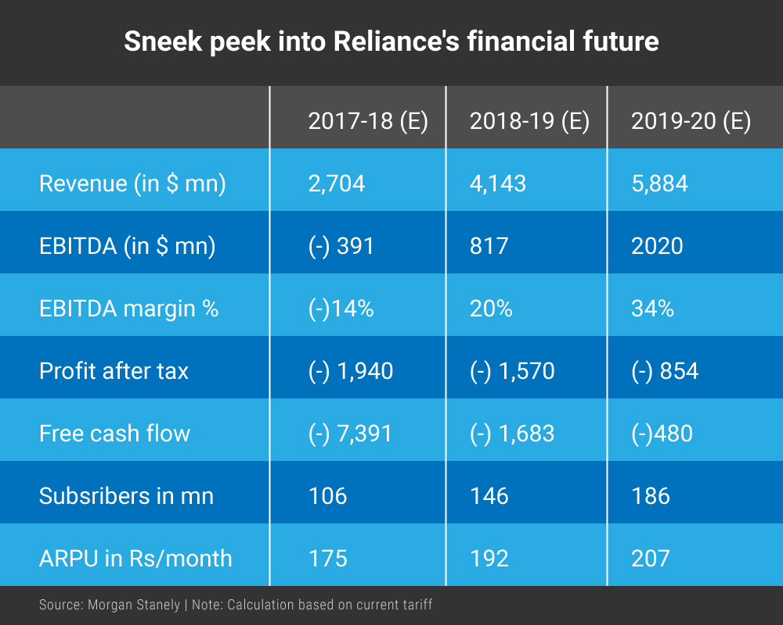](https://490z7i45htbb1f4tty9mdpi6-wpengine.netdna-ssl.com/wp-content/uploads/2017/09/Sneek_peek_into_Jio.jpg)

## New Technology Paradigms:

At the Reliance Annual General Meeting , Mukesh Ambani, Chairman and Managing Director of Reliance, officially announced the launch of Reliance Jio, and said that it was dedicated to realising Prime Minister Narendra Modi's vision of digital connectivity for 1.2 billion Indians. [He said](https://twitter.com/reliancejio/status/771230404120424448),

**I start with the newest and youngest member of the Reliance family – Jio.**

Ambani noted that in the next 20 years of human civilisation, we will collectively achieve more than what has been achieved in the last 300 years through advances in technology. He went on to claim that while India is currently ranked 155th for mobile broadband Internet access out of 230 countries, Jio will help India be among the top 10. Comparing Internet data to oxygen, Ambani said,

**Digital Technologies open the doors to this life. Life cannot survive without oxygen; data is the oxygen of digital life. So, supply of oxygen for digital life must never be unaffordable...Jio’s mission is to meet the exploding need of data for India, and to take our nation from data shortage to data abundance."**

Jio claims that its long-term goal is to realise the **Digital India** vision and ensure Indians have highest quality and quantity data access at affordable prices.

## 1.The best quality broadband network with highest capacity

Ambani claimed that Jio is the only mobile network in the country that is only 4G LTE. He elaborated, "This means that there is only 4G on the Jio network and not “mostly 2G, sometimes 3G and once-in-a-while 4G”.

He also noted that the network is future-ready and could be easily upgraded to support even more data, as technologies advance to 5G, 6G and beyond.

## 2. A world of affordable 4G smartphones and wireless IP device

Today, Reliance Digital is introducing a lineup of affordable 4G LTE smartphones under Reliance's LYF brand, starting at Rs 2,999 for 4G LTE and Rs 1,999 for Jio-Fi, a wireless IP device. Jio apps bouquet – worth Rs 15,000 for an annual subscription – will be complimentary for all active Jio customers up to December 31, 2017.

## 3. Applications and content

To give users better control over their account, Reliance has an app- [MyJio](https://play.google.com/store/apps/details?id=com.jio.myjio&hl=en" \t "_blank), which lets them manage their account, recharge linked accounts and view detailed statements of usage.

## 4. Superior digital service experiences

Ambani noted that they had redesigned the Jio sign-up experience and made it fully digital using an Aadhaar-based eKYC process. He said,

**Over the next four to six weeks we will have this process in all our stores across India. Any Jio customer carrying an Aadhaar card will be able to walk out of a Jio store with a working connection within 15 minutes.**

## 5. Affordable and simple tariffs

Coming to the most important point about tariffs, Ambani said,

**I have great pleasure in announcing that all voice calls for Jio customers will be absolutely free. Free voice calling across India, to any network at all times. And no domestic roaming charges."**

Additionally, Reliance aims to offer unlimited night LTE data, as a means to pass on the idle network capacity at night to customers. On data plans, Ambani noted,

**Data packs in the market have an effective rate of about Rs 250 per GB. With Jio, you pay five to 10 times lower – Rs 25-50 per GB.**

"Most legacy telecom providers have not built their networks for data or the Internet but for voice and SMS. As Internet revolution caught on, they have had to retrofit their legacy networks to deal with data and IP as afterthought," said Ambani, while claiming that Jio, on the other hand, had created an all-IP network.

With Jio, Ambani aims to make IP India’s digital mother tongue. On Jio's reach, he said,

**Today, Jio’s 4G network covers 18,000 cities and towns, and over two lakh villages. By March 2017, we will cover 90 percent of India’s population.**

## Future Technologies :

Reliance Jio has been utterly disruptive in the Indian Telecom market from the time it debuted its Jio 4G Volte network and plans back in 2016. Since then, Jio helmed by Mukesh Ambani’s Reliance Industries has set the market on fire and has even forced competitors to resort to drastic measures for survival. Though the Telecom sector as a whole and the incumbents incurred heavy losses, the customers benefitted from low priced data plans and other Jio products and services.

Jio or its parent company has the financial muscle to break into other products and services too. Every now and then, one or the other offers and product launches are hot in the news.

**Here are some of the products that Jio plans to bring out in the future:**

## 1. ****Jio**** VoWi-Fi

VoWi-Fi, as the name indicates, allows the users to call without a mobile signal using Wi-Fi. This is one simple yet effective feature to have! This is coupled with the Public WiFi service which Jio has been testing in various regions such as Madhya Pradesh, Andhra Pradesh, Telangana, and Kerala.

Now, if you’re thinking that this could be done via social media and Instant Messaging apps, then please note this is better than those options because it’s more seamless and works like the regular SIM calling (via dialer). On supported networks, your phone can switch calls between WiFi and cellular network depending on which one has stronger signals in your area. To start with, this would work for Jio to Jio calls only.

## 2. Jio GigaTV

This service would depend on the broadband connectivity offered by Jio GigaFiber listed above. Once you have their broadband connection, you can avail the plethora of Jio suite products or apps, 600+ channels and movies on your TV using a set-top box. It will support voice-commands using Microphone enabled remote which has inbuilt Google Assistant and will also integrate video-calling support.

## 3. Jio Smart Home

Jio already announced a handful of Smart Home products at Jio GigaFiber launch AGM. Next year, Jio will be bringing in more smart home products like smoke and water sensors, panic button, smart video doorbells, smart switches, etc. in India.

The idea is to make every access point smart so that you can control your entire home by conveniently using your smartphone as a remote.

## 4. Jio 5G

The company which has been the major driving force behind Digital India, thanks to its 4G LTE at an unbelievable low price would be launching their 5G services within five to six months after the spectrum allocation. Using Jio 5G, users will be able to download and upload data up to 50 to 60 times faster than on 4G.

## 5. Jio Smartphone

Jio phones could grab attention as they were basic phones with the 4G network connectivity and with some utilitarian apps like Whatsapp sprinkled into the small package. And now, top officials at Reliance Jio Infocomm say that they are working on affordable large-screen smartphones which would offer both high-quality content and high-speed connectivity to the Indian market.

As per reports, Jio has partnered with Flex, a US contract manufacturer as well as tech giants like Apple, Samsung, Xiaomi and Oppo for this endeavor.

## 6. Jio Cinema

Do you love Disney, Pixar, Marvel, Star Wars, etc? If yes, you’re in for a treat as the Jio Cinema app would host a dedicated section on the app for the aforementioned content. This is after a tie-up with the juggernaut of entertainment, i.e., Disney. This is one more reason to love the on-demand video streaming platform of Jio.

## 8. Jio Enterprise Solutions

We talked about Jio Smart home, Broadband and many other products for Households. This year, the company has been trying to build its roots in the ₹50,000-crore strong enterprise market as well. This is occupied by its major rival Bharti Airtel and state-run Bharat Sanchar Nigam Limited (BSNL). Its investment in the broadband and other IT frameworks, as well as the collab with Cisco, would mean it could sooner or later tap into this market.

**Jio Music**

## Image result for jiosaavn

In March 2018, Saavn signed a $1billion merger deal with Reliance Industries-owned JioMusic and after the full integration, the service was rebranded as JioSaavn.

The new JioSaavn app is the outcome of the acquisition of Saavn by Reliance Industries Limited (RIL)in March,2018. RIL officially merged its JioMusic app with Saavn to launch JioSaavn.

Jio also plans to add a suite of new in-app products and music experiences, including an interactive lyrics feature, localised vernacular display, custom integrations with concerts and live events, as well as exclusive video content which would be rolled out over the next few months.

Speaking on the launch of JioSaavn, Akash Ambani, Director, Reliance Jio, said, "JioSaavn represents a turning point for the music streaming industry in India, as the country continues to experience accelerated tech innovation, rapid adoption of digital services, and a digital music industry at par with global leaders. Powered by Jio's advanced digital services infrastructure and complemented by its widespread user base, JioSaavn will be the largest streaming platform in India."

The app boasts of a rich library of over 45 million songs across categories like Bollywood songs, English and International hits, Hindi chartbusters, independent Indian artists, and all Indian regional music.

With the merger, JioSaavn managed to increase its Monthly Active Users (MAUs) by more than 5x in a year. Vinodh Bhat, Co-founder, President and Chief Strategy Officer of JioSaavn said, “The integration with Jio has enabled us to create one of the largest, fastest-growing, and most capable media platforms in the world. Post the integration, our user base has grown significantly. The integration with JioMusic has allowed us to penetrate deeper into markets across the country. Since merging with JioMusic, we have made several changes to our infrastructure to support an unprecedented and massive scale. We expect geometric growth for music streaming in India as more and more people benefit from data connectivity.”

## COMPARATIVE ANALYSIS

**What exactly is different about Jio?**

The biggest difference between other telecom operators and Jio is their **optical fibre network.**An optical fibre is better than other cables because the data transfer capacity of optical fibre is very high compared to mobile towers.

Reliance Jio has the longest fibre optic network in the country, ranging over 2.5 lakh kilometers of fibre.

**How much money has Jio invested?**

Reliance Jio invested ₹ 150,000 Crores ($ 22 billion) into this fibre optic network.[[5]](https://www.quora.com/What-is-the-business-model-of-Reliance-Jio-How-are-they-offering-4G-data-at-such-cheap-rates-How-are-they-providing-unlimited-voice-calls-free-to-every-Jio-customer-How-are-they-offering-unlimited-4G-data-at-night#aStQi)

Put this in perspective - **this is more than two times the *combined* investment of Airtel, Idea and Vodafone** in the 4G segment (and remember that most of the other investments are not even complete as of now). [[6]](https://www.quora.com/What-is-the-business-model-of-Reliance-Jio-How-are-they-offering-4G-data-at-such-cheap-rates-How-are-they-providing-unlimited-voice-calls-free-to-every-Jio-customer-How-are-they-offering-unlimited-4G-data-at-night#JJtqX)

Now, if you are investing such a huge sum of money into the market - 4G market - which is still untested in India, how are you expecting to earn profit?

In other words, how exactly will they get back those ₹ 150,000 Crores?

In telecom, just like the horseless carriage syndrome of business, it stopped operators from being tech savvy. It was in 2012 that AIRTEL rolled country’s 1st 4g network in kolkata. But look at the pace that they rolled out.

The perfect “catch 22” of AVOID (airtel voda idea) is that they cant shut down their 2g/3g ops and benefit with jio is that as they have IP NETWORK, their back end can in real time shape all of it to run, milking the every last drop of spectrum.

TELENOR recently introduced 4g in the remaining circles that they are providing services, and launched 4G on lean tech, using only 5mhz of LIBERALIZED spectrum they won through bidding. Vodafone is now interested in buying telenor , but why?  
For the spectrum, so that they can fully use their spectrum holding in excess of 7.5 mhz to offer 4g in populous circles like UP EAST and Bihar.  
Telenor is also exiting India because of its poor spectrum holding, and as they also have to offer 2g, their half the spectrum is blocked for that.  
If you remember the net neutrality debate, it was all about “deep packet inspection”, and if u have used SKYPE, you know you can talk and chat over IP. According to regulator policies, skype has many restrictions, like you cant call any number in India while in India. Volte is nothing, but just JIO providing skype-like services, and that too for free. What happens when u call on skype, it pings other user within a second. Same is the case with volte. Ur calls get placed in blink of the eye, and deep packet inspection let the JIO servers know, u are on a VOICE CALL, so they will treat or give Your call a preference to go through a pipe that has limited flow at a time. But as soon as you end your call and there is no other person calling, the same pipe of 20 MHZ spectrum can be used to let you surf google or quora at full speeds.  
while in 2g calls, a fixed amount of flow is ALWAYS separated from the main culvret of spectrum.

Indian telecom industry off late was running as a cartel, with idea vodafone and airtel offering almost same plans and same offering in same price band. They had the upper hand of QoS and unmatched network with ties like INDUS TOWERS, with all three operators co-owning shares and BTS, which again brings down the capex. Also they had liquidity with them , which was absent with dual tech and other small players like aircel, rcom, mts bsnl tata. Since these 3 biggies dominated the sector and when we thought of respite through OTT APPS such as whatsapp for calling, they again came up with differential pricing.  
JIO has everything that these 3 biggies dont, a company with huge cash reserves, and most importantly a visionary leader, mukesh. They disrupt everything and everyone whenever they enter a new sector. This time they have solid OFC roll out, ofc connected bts and most importantly a govt in the centre which favors jio, which ultimately favors us all consumers. Rest operators TOWERS are still working on RF BACKHAUL, just the way ur home microwave works while heating ur food. In JIO, MOST OF THEM ARE FIBER CONNECTED, ONLY WHICH CAN ACTUALLY SERVE 100S OF DATA HUNGRY CUSTOMERS, WITH “TRUE” 4G SPEEDS.

Jio will not make money by selling anything cheap, but by buying or producing everything cheaper than anybody else can. It is a massive supermarket of digital services. It is about volume, but not just the volume of its customer base, but also the volume of offerings that its ecosystem contains and is designed for.

[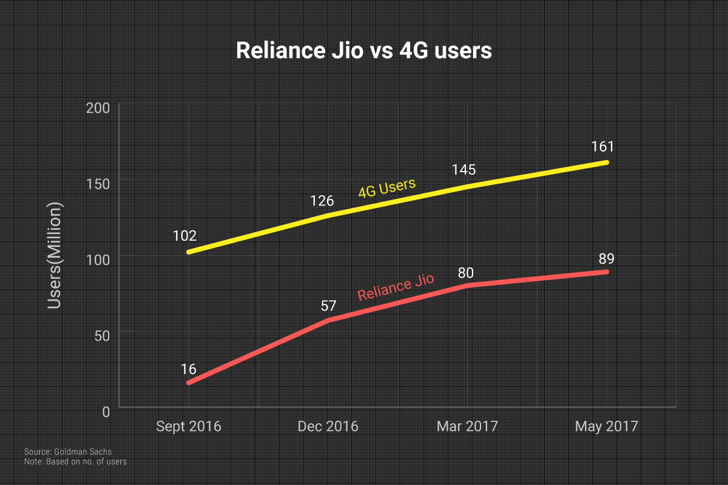](https://490z7i45htbb1f4tty9mdpi6-wpengine.netdna-ssl.com/wp-content/uploads/2017/09/Jio_vs_4G_users.jpg)

Jio TV and Jio Cinema are already [India’s #2 and #3](http://www.livemint.com/Consumer/PyTKS6GVjiZTmYY9C46hzK/Hotstar-top-video-streaming-app-in-India-report.html) video streaming apps. Internal numbers show JioTV has crossed 50 million downloads, and JioCinema, JioMusic and JioMags 10 million each. JioXpressNews offers ad-free reading in 10 Indic languages across 500 publications.

About 85% to 90% of traffic on Jio is for entertainment. “Jio TV is a replica of Tata Sky and more. There are 400 channels on its platform… all real time, and on mobile,” says a third Jio insider. Serials and news on channels such Zee and Sab TV are most watched.

[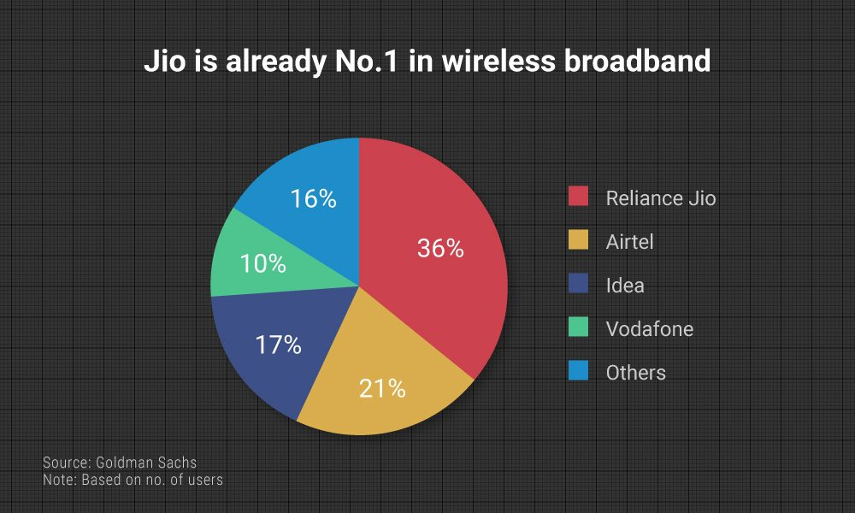](https://490z7i45htbb1f4tty9mdpi6-wpengine.netdna-ssl.com/wp-content/uploads/2017/09/Jio_No1.jpg)

Between August 2016, the month before Jio stepped into the market, and June 2017, Aircel, Tata Teleservices, Reliance Communication, and Telenor lost nearly six percentage points in market share — about three-fifths of 10.39% share that Jio had, [per data](http://www.trai.gov.in/sites/default/files/Press%20Release%20No.113_Eng.pdf) from the Telecom Regulatory Authority of India (TRAI).

The bloody price war showed on Airtel’s books, too. Its net profits dropped from Rs 1,460.7 crore in the quarter to September 2016 to Rs 367.3 crore in June 2017 ending quarter.

The pain may continue. “(The) telecom sector revenues could be impacted by positive 5% to negative 8% with a downward bias across various scenarios of conversions to the plans introduced by Jio as well as incumbents,” writes Saurabh Handa, analyst with Citi Research in a report titled Jio: Proving the Naysayers Wrong.

[[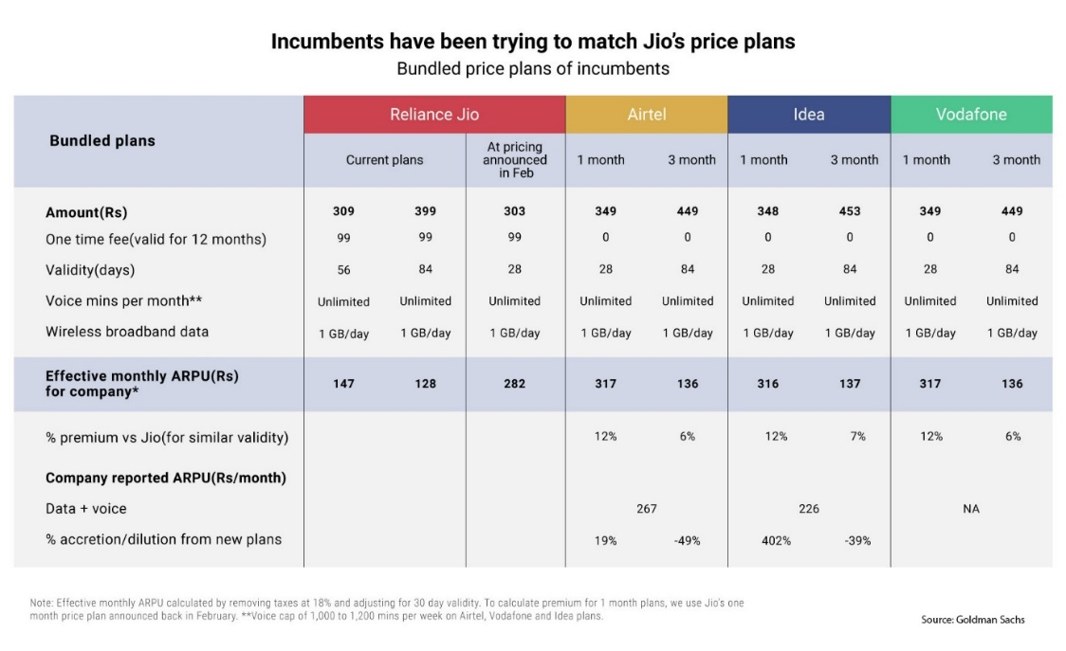](https://490z7i45htbb1f4tty9mdpi6-wpengine.netdna-ssl.com/wp-content/uploads/2017/09/Matching-Jio_price_plans.jpg)](https://490z7i45htbb1f4tty9mdpi6-wpengine.netdna-ssl.com/wp-content/uploads/2017/09/Matching-Jio_price_plans.jpg)

Already more than 100,000 towers have been set up. “In the next phase there will be a total of 1.5 lakh towers, which will cover 90% of the population,” said the third insider. At present Jio covers 80% of India’s population.  
The radio towers were low cost, too. The energy consumption is less than a kilowatt, comparable to three kilowatt on legacy towers. Executives FactorDaily spoke with said that the electronics are designed in such a manner that the towers can take extreme temperatures without air conditioning.

Then the network was also built on IP-based platform, which further helps in reducing the cost. The IP-based network the cost of servicing data and calls is as low as, say, eight paise for a one-minute voice call. For the incumbents the cost is 30 paise but this includes the contentious interconnection usage charge (IUC, which is what one operator pays another to land a call).

Jio claims the IUC of 14 paise for a call minute is based on legacy equipment costs and way too high. Incumbents hotly contest that.

[[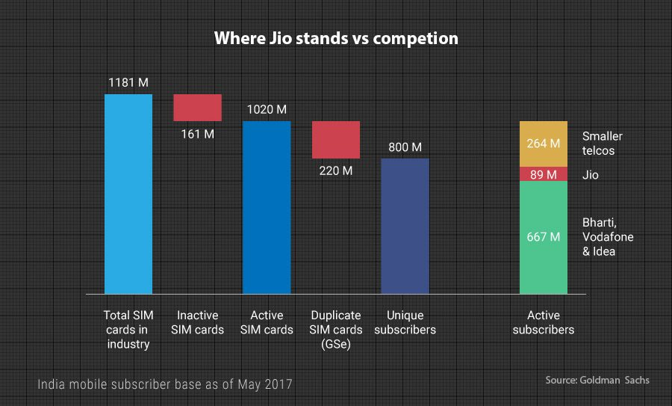](https://490z7i45htbb1f4tty9mdpi6-wpengine.netdna-ssl.com/wp-content/uploads/2017/09/Duplicate_SIM_phenomenon-1.jpg)](https://490z7i45htbb1f4tty9mdpi6-wpengine.netdna-ssl.com/wp-content/uploads/2017/09/Duplicate_SIM_phenomenon-1.jpg)

FactorDaily reviewed a presentation made by Reliance Jio to the government, in which Jio said that companies (like Airtel, Vodafone and Idea) do not want to reduce the IUC because it is a revenue earner. It said that in the last seven to eight years incumbents have not invested in legacy networks, which was for voice calls only, cost of which has already been recovered. The recent investments have been in building a data network for 3G and 4G. On these networks the IUC should be much lower, Jio argues.

If TRAI indeed cuts the IUC, as the industry expects, the impact on incumbent bottomlines could be painful. Operating profits of Airtel and Idea may shrink 7% to 9%, [estimates](http://www.livemint.com/Money/ySX6PmVONthU1Clo9D3XEM/Airtel-Idea-face-double-whammy-if-Trai-cuts-interconnection.html) Mint.

Such an outcome would favour Jio, which according to a senior executive, has just 5% of its network utilisation on voice. For incumbents, the comparable number is about 50% to 60%.

Incumbents beg to differ. “We have to run three networks — 2G, 3G and 4G… They are bound to have that because of 600 million 2G users. One cannot have a complete IP-based network,” says the first executive with an incumbent operator.

Analysts believe Jio is set to save money on calls. “We expect IUC will likely be revised down modestly in the upcoming review. Our sensitivity suggests Jio gets over Rs 25 to 30 savings per customer for a reduction in IUC from 14 paise to 8 paise, which it could pass to customers in the form of lower prices,” writes Navin Killa of UBS in a report.

**ACHIEVEMENTS:**

**1. Jio is the only all 4G all IP network in the world:** With over 100,000 sites, backed by state-of-the-art, all IP network, LTE spectrum across 800MHz, 1800MHz and 2300MHz bands, and largest fiber footprint, Jio has the widest LTE coverage in India than any other telecom player. Jio’s network to cover 99 per cent of India’s population. With Jio, India will soon have a larger 4G coverage than the 2G coverage set up over last 25 years by incumbents.

**2. Free Voice** becomes a reality in India as the market moves towards data.

**3. Mobile data consumption** in India went up from 20 crore GB per month to over 150 crore GB per month. Jio customers alone are consuming 125 crore GB of that data.

**4. India moves**from 155 to No. 1 in the world in terms of Mobile Data Consumption.

**5. Jio is the world’s first and only exabyte telecom network.**More than 100 crore GB data per month. Jio is already carrying five times more data than all other telecom players put together in India.

**6. Streaming Video** in excess of 165 crore hours per month.

**7. Voice traffic** of more than 250 crore minute per day.

**8. Time spent**by an average Indian on mobile each week is more than 7 times time spent on TV.

**9. Fastest ramp up of Subscribers** in the world by any technology company. It added seven customers every second reaching 100 million customers in just 170 days. Today over 130 million customers on Jio network.

**10. Data democratization:**Tariffs have become much more affordable having gone from between Rs. 250 - Rs. 4000 per GB at the time of Jio launch to less than Rs 50 per GB currently.

**11. Jio users pay even lesser** per GB per month with the current Rs 399 plan which offers 1 GB of high speed data per day for 84 days.

**12. Improving speeds:**The TRAI SpeedTest portal, which officially monitors the quality of telecom networks in India, has consistently ranked Jio as the clear 4G network leader in coverage, usage and data speeds month after month. It is also evident the average speeds available to consumers today are consistently improving.

**13. Number of broadband customers:** As on 31 August 2016 the total wireless broadband subscribers were about 154 million. Post Jio this subscriber base has grown exponentially and as per TRAI data the wireless broadband subscriber count was over 282 million as on 30 June 2017.

**14. Tariff simplification:**Prior to Jio there were nearly 16000 plans available to confuse consumers. Post Jio all operators are trying to replicate the Jio model by trimming the number of plans being offered. Jio introduced only a few simple tariff plans with just one or two plans that were considered marquee plans any any point in time.

**15. Exponential growth**of digital ecosystem: All key social media applications and content providers like Facebook, Youtube and others have seen enhanced user base in India. India has become most active market for Google and Facebook (70 million additions post Jio). Also, six million units of the JioPhone sold on the first day.

## CORPORATE SOCIAL RESPONSIBILITY

Reliance Industries Limited strongly believes in inclusive economic growth. The Company’s CSR initiatives are based on this principle, and resonate with India’s National Development Goals as well as the Sustainable Development Goals (SDGs) outlined in the United Nations 2030 Agenda for Sustainable Development.

Most of the CSR activities of the Company are carried out under the aegis of Reliance Foundation (RF), which in a span of seven years has emerged as a leading corporate foundation addressing nation’s multiple development challenges. The Foundation was established in 2010 under the leadership of Smt. Nita M. Ambani.

Reliance has strategically chosen the company’s CSR initiatives with a focus on improving the quality of life. The initiatives focus on the following areas: Rural Transformation, Health, Education, Sports for Development, Disaster Response, Arts, Culture and Heritage and Urban Renewal.

The following sections present an overview of various CSR initiatives taken up by the Company.

## Rural Transformation

## 

Livelihoods of 1.2 million+ farmers, fisherfolk and livestock owners enhanced (over 4.8 million since inception). Perennially, India’s farmers have faced the challenge of establishing market linkages. To help the farmers overcome this challenge, Reliance empowers them to set up Farmer Producer Companies (FPCs). These farmer-owned and farmer-driven companies sensitise rural producers on the need to come together as collectives, aggregate farm produce to bring in economies of scale for fetching better prices, have sustainable access to markets, etc.This aggregation also enhances the bargaining power of farmers. So far, Reliance has mentored 19 FPCs, spanning 10 states. As on 31st March 2018, the RF-mentored FPCs had 21,500 farmers associated with them. During FY 2017-18, the annual turnover of FPCs was Rs.67.5 crore. Each farmer who transacted through FPCs, on an average had an additional income of Rs.5,000 to Rs.6,000.

For efficient water management, user groups were formed across 260 villages that manage and regulate sustainable water use. Assessments show that the intervention has positively impacted farmer livelihood in terms of land use pattern, cropping intensity and income levels.Reliance supported Paani Foundation’s Water Cup initiative to ensure water security in rural Maharashtra. Through this initiative, over 96 billion litres of water storage capacity has been created across 1,300+ villages.

## Health

## 

## The health programmes of the company have reached out to 2.5 million people and provided over 4.5 million patient consultations since inception. Through partnerships, Reliance supported several organisations working in the field of healthcare in providing a range of services, both at primary and tertiary level.

The Dhirubhai Ambani Hospital at Lodhivali near Patalganga (Maharashtra), has provided free and subsidised healthcare to 1,923 patients in this financial year, taking the number of total subsidised patients to 18,600 since inception. A majority of these patients include the underprivileged, senior citizens, and trauma victims from the economically weaker sections of the society.

## For more than a decade, through RF Drishti programme, Reliance has been supporting visually impaired underprivileged people to undergo corneal transplants by partnering with the National Association for the Blind, Arvind Eye Hospital and Sankara Eye Foundation. This year, 1,207 visually impaired individuals were supported under the programme (17,031 corneal transplants since inception).

## Education

## 

## Initiatives of Reliance in the education space are aimed at promoting primary and secondary education and enabling higher education through merit-cum-means scholarships across the country. Reliance has been leveraging appropriate technologies and learning resources for improving the quality of teaching and, in turn, student performance.

## To diversify its initiatives in education space, Reliance supported various organisations in providing quality education to children from underprivileged communities. Through these partnerships, Reliance is improving the learning outcomes of over a lakh children across the country. The company is providing quality education to 16,000 students through 14 Reliance Foundation Schools and 713 talented students were given scholarships to pursue higher studies (over 13,644 scholarships since inception).

**Sports for Development**

**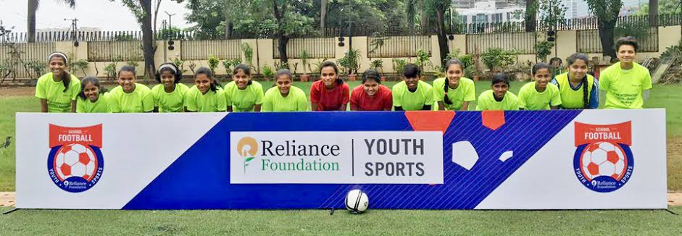**

Using sports as a vehicle, Reliance promotes health, fitness and active lifestyle to bring about a positive change among youth and children in both urban and rural landscapes. Popular sports such as football, basketball and athletics are used to cultivate strategic thinking, competitive spirit and leadership abilities among children and youth. Reliance partners with various national and state sports bodies in improving the quality of sporting ecosystem through better facilities, training, infrastructure and equipment.

Reliance Foundation Youth Sports (RFYS) provides a nation-wide unique platform for promoting grassroots sports. In 2007, the programme continued with football and introduced athletics to further identify and encourage sporting talent across the country.

The programme strategically partnered with 20 institutes across the country for effective implementation. On the ground, the tournaments were conducted by officials from Athletics Federation of India and All India Football Federation. Reliance further donated equipment to the participating institutes to promote sports. For motivating young talent and expanding the reach of RFYS, all final matches at city level, zonal level and national level were live-streamed on the RFYS website.

The RF Jr. NBA programme has scaled up to 10,000+ schools across 34 cities through its physical education curriculum. So far, the programme has inspired 9 million children and youth to adopt healthy, active lifestyleThe RF Young Champs programme is supporting 48 talented young football players through scholarships to hone their skills with world-class facilities and best-in-class trainingsIn its second year, RF Youth Sports programme introduced athletics while continuing with football. The programme reached out to 4.7 million youth from 3,400+ educational institutions across 34 cities

**Disaster Response**

**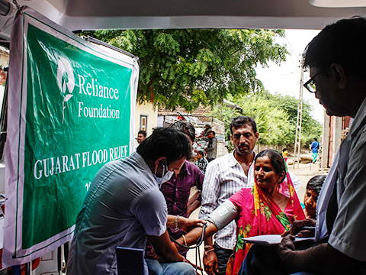**

Reliance aspires to respond swiftly and effectively to disasters that endanger human lives and livelihoods, by directly engaging with affected communities. It leverages all its strengths – including human resources and information technology – to provide relief and rehabilitation support. During FY 2017-18, the Company promptly helped communities affected by floods and cyclone in Assam (Supported over 10,000 individuals from 22 flood affected villages across Assam’s 11 districts), Gujarat(Helped over 0.15 million individuals from 87 flood affected villages across 2 districts of Gujarat. Adopted four worst-hit villages to provide required assistance for rehabilitation, beyond the immediate relief efforts) and Ockhi(The early warning advisories disseminated during Ockhi cyclone in Southern India saved lives of 27,000 fishermen and over 4,600 Ha of paddy fields).

**Arts, Culture and Heritage**

**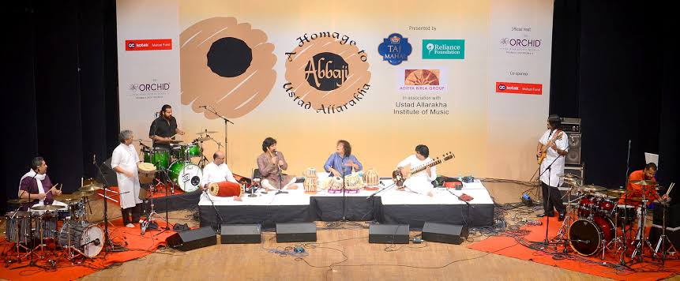**

Reliance works to preserve the rich heritage, art and culture of India for its future generations and makes conscious efforts to improve the livelihood opportunities for traditional artisans and craftsmen. This is done primarily by undertaking various promotional projects and documenting India's heritage for the benefit of future generations. The company supported ‘8 Prahar’, an event dedicated to Indian classical music, bringing together singers including Padma Vibhushan Sangeet Martand Pandit Jasraj to delight music lovers in Mumbaiand the annual concert ‘Abbaji’, organised by Ustad Zakir Hussain in the memory of renowned tabla maestro, Ustad Allah Rakha Khan.

**CONCLUSION**

In the year 1966 the RIL was founded by Shri Dhirubhai H.Ambani, it was started as a small textile manufacturer unit. In May 8, 1973 RIL was incorporated and conformed their name as RIL in the year 1985. Over the years, the company has transformed their business from manufacturing of textiles products into a petrochemical major. In the year 1995-96, the company entered the telecom industry through a joint venture with NYNEX, USA and promoted Reliance Telecom Private Limited in India.

Reliance became the first corporate in Asia to issue bonds in the U.S at the year of 1996-97. Reliance Industries Limited or RIL is India’s largest private sector company. Further, it has businesses across India and is engaged in petrochemicals, energy, exploring and producing hydrocarbons, textiles, retail, telecommunications, and natural resources.While the company has more than 30 lakh shareholders, the Ambani family holds nearly 52% of the total shares. Also, the company has over 24,000 employees and had a revenue of Rs. 2,960 billion in 2015-16.

RIL aims to touch the lives of people in a positive way. Further, Reliance believes in inclusive growth as a universal concept and conducts its business in accordance with the same.

## Bibliography

* <https://en.wikipedia.org/wiki/Jio>
* ‘JIO visit documentation’ by PIC committee of RGIT.
* <http://factordaily.com/>
* <https://www.ril.com/TheRelianceStory.aspx>
* <https://www.news18.com/news/tech/reliance-jio-growth-in-numbers-just-how-much-has-jio-grown-in-one-year-1801733.html>
* <https://www.google.com/search?q=report+on+jio+network+advantages+over+other+networks&rlz=1C1CHBF_enIN816IN816&oq=report+on+jio+network+advantages+over+other+networks&aqs=chrome..69i57.29355j0j0&sourceid=chrome&ie=UTF-8>
* <https://en.wikipedia.org/wiki/Jio#cite_note-35>
* <https://www.indiastudychannel.com/forum/147953-Reliance-Jio-4G-LTE-services-disadvantages-and-hidden-costs.aspx>
* <https://www.businesstoday.in/sectors/telecom/reliance-jiofiber-airtel-v-fiber-broadband-plans-internet-speed-price-comparison/story/378280.html>
* <https://www.toppr.com/guides/commercial-knowledge/business-organizations/company-overview-of-ongc-reliance-industries-sbi/>
* <https://www.referenceforbusiness.com/history2/78/Reliance-Industries-Ltd.html>